A DYNAMIC PHISHING URL DETECTION SYSTEM INTEGRATING ADVANCED MACHINE LEARNING AND CROWDSOURCED THREAT INTELLIGENCE
(PhishGuard)
A project report submitted in partial fulfilment of the requirements for the award of the degree of
BACHELOR OF TECHNOLOGY
in
COMPUTER SCIENCE AND ENGINEERING (DATA SCIENCE)
Submitted by
D.ANISH MEGHAN | 23K91A6750
B.AKSHAYA | 23K91A6737
B.TANUJA | 23K91A6736
CH.SAI CHETHAN | 23K91A6742
Batch A3 (CSE - Data Science, Section A)
Under the esteemed guidance of
Mr. G. Ravi
[DESIGNATION]
[COLLEGE LOGO]
DEPARTMENT OF COMPUTER SCIENCE AND ENGINEERING (DATA SCIENCE)
[COLLEGE NAME]
[COLLEGE ADDRESS / AFFILIATING UNIVERSITY]
[ACADEMIC YEAR]

[COLLEGE LOGO]
[COLLEGE NAME]
DEPARTMENT OF COMPUTER SCIENCE AND ENGINEERING (DATA SCIENCE)
CERTIFICATE
This is to certify that the project report entitled "A Dynamic Phishing URL Detection System Integrating Advanced Machine Learning and Crowdsourced Threat Intelligence (PhishGuard)" is a bonafide record of the work carried out by D.ANISH MEGHAN (23K91A6750), B.AKSHAYA (23K91A6737), B.TANUJA (23K91A6736), CH.SAI CHETHAN (23K91A6742), in partial fulfilment of the requirements for the award of the degree of Bachelor of Technology in Computer Science and Engineering (Data Science), during the academic year [ACADEMIC YEAR], under my supervision.

Project Guide  Mr. G. Ravi  [DESIGNATION] | Head of the Department  [HOD NAME]  Department of Computer Science and Engineering (Data Science) | External Examiner  [NAME AND SIGNATURE]
DECLARATION
We hereby declare that the project report entitled "A Dynamic Phishing URL Detection System Integrating Advanced Machine Learning and Crowdsourced Threat Intelligence (PhishGuard)", submitted to the Department of Computer Science and Engineering (Data Science), [COLLEGE NAME], in partial fulfilment of the requirements for the award of the degree of Bachelor of Technology in Computer Science and Engineering (Data Science), is a record of original work carried out by us under the guidance of Mr. G. Ravi, [DESIGNATION]. The results embodied in this report have not been submitted to any other university or institution for the award of any degree or diploma.

D.ANISH MEGHAN | 23K91A6750
B.AKSHAYA | 23K91A6737
B.TANUJA | 23K91A6736
CH.SAI CHETHAN | 23K91A6742
Place: [PLACE]
Date: [DATE]
ACKNOWLEDGEMENT
We express our sincere gratitude to our project guide, Mr. G. Ravi, [DESIGNATION], for valuable guidance, encouragement and constructive suggestions throughout this project.
We thank [HOD NAME], Head of the Department of Computer Science and Engineering (Data Science), for providing the facilities and support needed to complete this work, and [PRINCIPAL NAME], Principal, [COLLEGE NAME], for the encouragement given to us.
We thank the project coordinators and all faculty and staff members of the department for their help, and our families and friends for their constant support.
We also acknowledge the authors of the base paper, Layan Aldhuwayhi and Arwa Alromih, and the authors and maintainers of the open-source software on which PhishGuard is built, in particular scikit-learn, XGBoost, pandas, Flask, React and Vite, and the providers of the public datasets and threat feeds that were used.

D.ANISH MEGHAN
B.AKSHAYA
B.TANUJA
CH.SAI CHETHAN
ABSTRACT
Phishing websites steal credentials and financial data by imitating trusted sites, and new phishing domains appear daily, many living only a few hours. Blacklists and manually updated databases fail on such zero-day URLs, static rules are easy to evade, and classifiers trained once age as attacks change. The base paper by Aldhuwayhi and Alromih (IEEE Access, 2026) proposes a dynamic framework that combines a machine-learning classifier with a crowdsourced feedback loop.
This project builds PhishGuard, a working implementation of that three-stage design. A balanced sample of 40,000 labelled URLs is cleaned and turned into 47 offline features (23 lexical, 9 structural, 15 domain) with human-readable red flags. Random Forest, XGBoost and Logistic Regression are compared on the same 80/20 split. At check time a confirmed community verdict, phishing or safe, overrides the model; otherwise the best model scores the URL, a reputation discount and pending votes adjust the score, and thresholds of 0.35 and 0.60 give safe, suspicious or phishing. Two net votes, or one trusted-feed report, confirm a URL; confirmed URLs are added to the training data and the models are retrained and hot-reloaded. A Flask API, a command-line interface and a seven-page React interface make the system usable.
On 8,000 held-out URLs the selected XGBoost model reaches accuracy 92.93 %, F1 92.88 % and ROC-AUC 0.981; 5-fold cross-validation gives F1 92.56 %. Random Forest scores F1 92.47 % and Logistic Regression 81.80 %. A check takes 8.0 ms through the API. In a live run, two community reports turned a lookalike page the model had scored at 9.5 % into a phishing verdict at once, a feed sync added 800 real URLs, and a retrain produced model version 2. Retraining with random in-distribution URLs did not change the average score. These results come from one 40,000-URL dataset and are not comparable with the base paper's 99.8 % on 235,804 URLs; 95 automated checks pass, and no user-acceptance, load or authentication testing has been done.
Keywords: phishing detection, URL classification, crowdsourced threat intelligence, XGBoost, Random Forest, adaptive security, web application.
TABLE OF CONTENTS
CHAPTER 1 INTRODUCTION 1
1.1 Domain Overview 1
1.2 Background and Motivation 2
1.3 Problem Statement 2
1.4 Need for the System 3
1.5 Objectives 3
1.6 Scope of the Project 3
1.7 Key Contributions 4
1.8 Limitations and Assumptions 5
1.9 Organisation of the Report 6
CHAPTER 2 LITERATURE SURVEY 7
2.1 Overview of the Literature 7
2.2 Base Paper Analysis 7
2.3 Related Work 8
2.4 Datasets and Algorithms in the Literature 10
2.5 Strengths and Limitations of Existing Work 10
2.6 Research Gap 11
2.7 Novelty against the Base Paper 11
CHAPTER 3 FEASIBILITY STUDY 13
3.1 Technical Feasibility 13
3.2 Economic Feasibility 13
3.3 Operational Feasibility 14
3.4 Schedule Feasibility 14
3.5 Advantages and Constraints 14
CHAPTER 4 SYSTEM REQUIREMENTS AND ANALYSIS 16
4.1 Existing System and its Limitations 16
4.2 Proposed System and its Advantages 16
4.3 Functional Requirements 17
4.4 Non-Functional Requirements 17
4.5 Hardware and Software Requirements 18
4.6 User Roles and Constraints 18
CHAPTER 5 SYSTEM DESIGN 19
5.1 System Architecture 19
5.2 High-Level Workflow 20
5.3 Data-Flow Diagrams 20
5.4 UML Diagrams 23
5.5 Database Design 28
5.6 Module Design 29
5.7 User Interface Design 29
CHAPTER 6 METHODOLOGY AND SOFTWARE IMPLEMENTATION 32
6.1 Overall Methodology 32
6.2 Dataset 32
6.3 Data Preprocessing and Feature Extraction 33
6.4 Algorithm Choice and Justification 35
6.5 Mathematical Formulation 35
6.6 Model Training and Evaluation 36
6.7 Application Architecture 37
6.8 Key Code Walkthroughs 38
6.9 Implementation Decisions and Reasoning 39
6.10 API Design 40
6.11 Security and Error Handling 40
6.12 Installation and Execution 41
CHAPTER 7 SYSTEM TESTING 42
7.1 Testing Strategy 42
7.2 Unit Testing 42
7.3 Integration Testing 43
7.4 Functional Testing 43
7.5 Security Testing 43
7.6 Validation and Edge Cases 44
7.7 Performance Testing 44
7.8 User Acceptance Testing 45
7.9 Limits of the Testing Done 45
CHAPTER 8 RESULTS AND OUTPUT SCREENS 47
8.1 Output Screens 47
8.2 Model Performance 53
8.3 Threshold, Feature and Data Analysis 55
8.4 Crowdsourcing and Retraining Results 59
8.5 Comparison with the Base Paper 61
8.6 Sample Inputs and Outputs 61
8.7 Success and Failure Analysis 62
8.8 Limitations of the Results 63
8.9 Objectives against Outcomes 63
CHAPTER 9 CONCLUSION 65
9.1 Summary of the Work 65
9.2 Objectives Achieved 65
9.3 Key Findings 65
9.4 Practical Applications 66
9.5 Known Limitations 67
CHAPTER 10 FUTURE SCOPE 68
10.1 Improvements 68
10.2 Additional Features 68
10.3 Scalability and Deployment 68
10.4 Further Research 69
REFERENCES 70
APPENDIX A IMPORTANT CODE 72
A.1 Feature extraction (phishguard/features.py) 72
A.2 Training and evaluation (phishguard/train.py) 73
A.3 Threat intelligence (phishguard/threat_intel.py) 73
A.4 Real-time decision (phishguard/detector.py) 74
A.5 Retraining (phishguard/retrain.py) 75
A.6 API layer (backend/server.py) 75
APPENDIX B INSTALLATION AND USER GUIDE 77
B.1 Installation 77
B.2 User guide 77
B.3 Troubleshooting 77
APPENDIX C ADDITIONAL SCREENS 78

LIST OF FIGURES
Fig. 5.1: System architecture of PhishGuard 19
Fig. 5.2: High-level workflow: from dataset to a self-refining detector 20
Fig. 5.3: Data-flow diagram, level 0 (context) 21
Fig. 5.4: Data-flow diagram, level 1 22
Fig. 5.5: Data-flow diagram, level 2 (the check path) 23
Fig. 5.6: Use-case diagram 24
Fig. 5.7: Sequence diagram: check a URL, report it, refine the model 25
Fig. 5.8: UML class diagram of the Python modules 26
Fig. 5.9: Flowchart of the core algorithm (decision order of detector.check) 27
Fig. 5.10: Entity-relationship diagram 28
Fig. 5.11: Check URL screen: verdict, probability gauge and risk scale 30
Fig. 5.12: Models screen: comparison, confusion matrix and feature importances 30
Fig. 6.1: Class balance and URL length distribution of the training data 33
Fig. 7.1: Extended test suite: checks passed by category 42
Fig. 7.2: Measured response times 45
Fig. 8.1: Landing page 47
Fig. 8.2: Check URL: phishing verdict 48
Fig. 8.3: Check URL: safe verdict 48
Fig. 8.4: Check URL: community overrides the model 49
Fig. 8.5: Check URL: false positive corrected 49
Fig. 8.6: Batch check of ten URLs 50
Fig. 8.7: Report a URL 51
Fig. 8.8: Threat intelligence board 51
Fig. 8.9: Models: full page (version 1) 52
Fig. 8.10: Models: after retraining (version 2) 52
Fig. 8.11: Comparison of the three classifiers on five metrics 53
Fig. 8.12: Confusion matrices on the 8,000 test URLs 54
Fig. 8.13: ROC curves of the three models 54
Fig. 8.14: F1 of each fold and the mean, per model 55
Fig. 8.15: Precision, recall and F1 against the threshold 56
Fig. 8.16: Deployed verdicts on the test set 56
Fig. 8.17: Top-10 feature importances of the XGBoost model 57
Fig. 8.18: F1 of XGBoost with different feature subsets 58
Fig. 8.19: XGBoost F1 and accuracy against the amount of training data 58
Fig. 8.20: F1 before and after retraining (note the different test sets) 59
Fig. 8.21: F1 before and after adding confirmed URLs 60
Fig. 9.1: Summary: the three classifiers on the held-out test set 66
Fig. C.1: Check URL: home 78
Fig. C.2: Check URL: full result page 78
Fig. C.3: Threat-intelligence entry 78
Fig. C.4: Models: comparison (version 1) 78
Fig. C.5: Activity 79
Fig. C.6: Activity: full page 79
Fig. C.7: Feed sync: dialog 79
Fig. C.8: Feed sync: result 79
Fig. C.9: Threat intelligence after sync 80
Fig. C.10: Retrain: confirmation 80
Fig. C.11: Retrain: running 80
Fig. C.12: Models: full page (version 2) 80
Fig. C.13: Threat intelligence after retraining 81
Fig. C.14: Dark theme 81

LIST OF TABLES
Table 1.1: Project objectives and where each is implemented 3
Table 1.2: Organisation of the report 6
Table 2.1: Summary of the base paper 7
Table 2.2: Comparison of selected related work (as summarised in [1]) 9
Table 2.3: Strengths and limitations of the reviewed literature 10
Table 2.4: Differences between the base paper and PhishGuard 11
Table 3.1: Technical feasibility checks 13
Table 3.2: Project phases 14
Table 3.3: Advantages and constraints 14
Table 4.1: Limitations of the existing system 16
Table 4.2: Functional requirements 17
Table 4.3: Non-functional requirements 17
Table 4.4: Hardware and software requirements 18
Table 4.5: User roles 18
Table 5.1: Schema of the SQLite database (phishguard/threat_intel.py) 28
Table 5.2: Module breakdown 29
Table 6.1: End-to-end pipeline 32
Table 6.2: Dataset facts 32
Table 6.3: Lexical (23) features 34
Table 6.4: Structural (9) features 34
Table 6.5: Domain (15) features 34
Table 6.6: Classifiers and settings 35
Table 6.7: Training configuration and cost 36
Listing: ThreatIntel._consensus 38
Listing: retrain.retrain (excerpt) 38
Listing: Detector.check (excerpt) 38
Table 6.8: Main implementation decisions 39
Table 6.9: JSON API (port 8103) 40
Listing: Abridged JSON response 40
Listing: Manual start 41
Table 6.10: Command-line interface 41
Table 7.1: Test suites 42
Table 7.2: Unit tests 42
Table 7.3: Integration checks 43
Table 7.4: Functional checks 43
Table 7.5: Security checks 44
Table 7.6: Validation and edge cases 44
Table 7.7: Measured response times 44
Table 8.1: Held-out test results of the three classifiers 53
Table 8.2: 5-fold cross-validation (mean +- standard deviation, %) 54
Table 8.3: XGBoost on the 8,000 test URLs at different probability thresholds 55
Table 8.4: Feature ablation (XGBoost refitted, threshold 0.5) 57
Table 8.5: Verdict before and after two community reports (demonstration run) 59
Table 8.6: Model metrics before and after the retraining demonstration 59
Table 8.7: Effect of adding confirmed URLs to training (mean of 3 draws) 60
Table 8.8: PhishGuard against the base paper (different datasets and conditions) 61
Table 8.9: Verdicts of the live detector on a hand-written set of 14 URLs (empty community store) 61
Table 8.10: The most confident errors of the XGBoost model on the test set 62
Table 8.11: Objectives measured against outcomes 63
Table 9.1: Objectives and their status 65
Listing: extract_features 72
Listing: build_models 73
Listing: ThreatIntel.report 73
Listing: ThreatIntel._consensus 74
Listing: Detector.check 74
Listing: retrain 75
Listing: build_app 75
Table B.1: How to use the main screens 77

LIST OF ABBREVIATIONS
Abbreviation | Expansion
API | Application Programming Interface
AUC | Area Under the (ROC) Curve
CLI | Command-Line Interface
CORS | Cross-Origin Resource Sharing
CSV | Comma-Separated Values
CV | Cross-Validation
DFD | Data-Flow Diagram
DNS | Domain Name System
ER | Entity-Relationship
F1 | Harmonic mean of precision and recall
FN / FP | False Negative / False Positive
FPR | False-Positive Rate
HTTP | Hypertext Transfer Protocol
JSON | JavaScript Object Notation
LR | Logistic Regression
LSTM | Long Short-Term Memory
ML | Machine Learning
RF | Random Forest
ROC | Receiver Operating Characteristic
SQL | Structured Query Language
TLD | Top-Level Domain
TN / TP | True Negative / True Positive
UI | User Interface
UML | Unified Modeling Language
URL | Uniform Resource Locator
WHOIS | Domain registration lookup protocol
XSS | Cross-Site Scripting

CHAPTER 1
INTRODUCTION

1.1 Domain Overview
Phishing is a form of social engineering in which an attacker imitates a trusted organisation, such as a bank, a shop, a mail provider or a government service, to make a victim reveal credentials, payment details or other personal data [20]. The attack usually ends in a web page: the victim receives a message, follows a link, and meets a page that looks like the real site. The link is therefore the single artefact that every phishing campaign needs, and it is the object that this project analyses.
Defending against phishing at the link level is attractive because the Uniform Resource Locator (URL) is small, always available and cheap to inspect. A URL can be examined before the page is fetched, which keeps the victim away from malicious content and avoids the cost and risk of downloading it. The weakness of the approach is that attackers choose the URL. They register new domains, hide the brand name inside sub-domains or paths, add credential-related words, and abandon a domain within hours. Any defence has to keep up with that speed.
Three families of defence are in common use. Blacklists such as those behind browser warnings record URLs that someone has already reported. Rule-based filters flag fixed patterns such as an IP address in place of a host name. Machine-learning (ML) classifiers learn the difference between phishing and legitimate URLs from labelled examples [18], [19]. Each has a known limit: a blacklist is blind to a URL that has not been reported yet, a fixed rule is easy to evade, and a classifier trained once ages as attack patterns change [1].

1.1.1 Why combine machine learning with community reports
The base paper of this project argues that the weaknesses are complementary [1]. A classifier can score a URL that has never been seen, and it needs no list. A community of users and public threat feeds can recognise a new attack within hours, before a model could learn from it, and can also point out when a classifier is wrong. Feeding confirmed community verdicts back into the classifier closes the loop. This is the design that PhishGuard implements.

1.2 Background and Motivation
The base paper reports that phishing affects more than 83 % of businesses and cost companies about USD 17.4 billion in 2024 [1]. Those figures come from the paper's own sources and are quoted here as context, not as results of this project. What matters for this work is the pattern that the paper describes in its introduction: most published detectors reach very high accuracy on a static benchmark, yet they are trained once, they have no structured way to take in new attacks, and they do not turn user reports into training data [1].
The motivation of the project is to show that the three-stage idea of the base paper can be built end to end with ordinary tools, run on an ordinary computer, and be inspected by its users. The aim is a working system, not a larger benchmark score. The project therefore chose interpretable URL features, three classical classifiers that train in seconds, a transparent vote-based community store, and a web interface that explains every verdict.
- Speed of attacks. New phishing domains appear daily and many live only a few hours, so any list is behind.
- Reachability of the evidence. Only the URL is needed. No page is downloaded, so the check is fast and safe.
- Human knowledge. Users and security communities notice attacks first; the system should be able to use that knowledge at once.
- Trust. A verdict is only useful if the user can see why it was given, so the system lists red flags and the reason.

1.3 Problem Statement
Phishing websites continue to steal user credentials and financial data at scale. Blacklist-based methods cannot detect newly created, zero-day phishing URLs. Static rules and one-time-trained models fail as attack patterns evolve, and high false-positive rates in existing filters block legitimate websites and reduce user trust.
Need. An adaptive phishing detection system that classifies unseen URLs with machine learning and stays current through crowdsourced threat intelligence.
Formal statement. Given a URL string u, produce a verdict in {phishing, suspicious, safe} with a probability and a human-readable explanation, using (i) a classifier trained on labelled URLs and (ii) a store of community-confirmed verdicts that can override the classifier and can be added to its training data; and make the system available through a web interface that answers in real time.

1.4 Need for the System
- Blacklists miss zero-day URLs, so a learned model is needed for URLs that no one has reported.
- A model alone cannot know about a campaign that started this morning, so a community channel is needed.
- A model alone will sometimes be wrong about a legitimate site, so the community must also be able to say "this one is safe".
- Retraining by hand is slow, so the system must retrain itself from confirmed reports and load the new model without a restart.
- Users do not trust a bare label, so every verdict must come with its reasons.

1.5 Objectives
The six objectives set at the start of the project, and the part of the system that addresses each, are listed below. How far each was achieved is assessed in Chapter 8 and Chapter 9.
Table 1.1: Project objectives and where each is implemented
No. | Objective | Where it is implemented
1 | Collect and preprocess a dataset of phishing and legitimate URLs | data/urls_sample.csv (40,000 URLs); phishguard/data.py
2 | Extract lexical, structural and domain-based URL features | phishguard/features.py (47 features)
3 | Train and compare Random Forest, XGBoost and Logistic Regression | phishguard/train.py
4 | Integrate crowdsourced threat intelligence for newly reported phishing URLs | phishguard/threat_intel.py; decision order in detector.py
5 | Refine the model continuously as new threat data arrives | phishguard/retrain.py; hot reload in detector.py
6 | Provide real-time URL classification through a simple web interface | Flask API (port 8103) and React UI (port 5103)

1.6 Scope of the Project

1.6.1 In scope
- Classification of a single URL or a pasted or uploaded batch of up to 100 URLs, in real time.
- 47 offline URL features in three groups, with a plain-language list of red flags.
- Comparison of three classifiers on one 40,000-URL dataset with a fixed 80/20 split, plus 5-fold cross-validation.
- A SQLite store of community reports with vote counting, consensus, and optional import from two public feeds.
- Retraining from confirmed reports, with automatic reload of the new model.
- A React web interface (seven pages) over a Flask JSON API, a command-line interface, and the original Flask pages.

1.6.2 Out of scope
- Downloading or rendering the page behind a URL, and any WHOIS, DNS or certificate lookup.
- E-mail, SMS or attachment analysis, and image or logo comparison of the page.
- User accounts, authentication, moderation workflows and administrator verification of reports.
- Browser extensions, mail-gateway plug-ins and deployment at internet scale.
- Deep-learning models; the base paper's LSTM network is not reproduced.

1.7 Key Contributions
1. A complete, working implementation of the base paper's three-stage design (feature extraction, ML classification, crowdsourced refinement) that runs offline on one Windows computer.
2. A 47-feature offline URL extractor (23 lexical, 9 structural, 15 domain) with human-readable red flags; extraction takes 0.08 ms per URL.
3. A controlled comparison of Random Forest, XGBoost and Logistic Regression: the selected XGBoost model reaches F1 92.88 % and ROC-AUC 0.981 on 8,000 held-out URLs and F1 92.56 % in 5-fold cross-validation.
4. A transparent crowdsourced threat-intelligence store: vote-based consensus, trusted public feeds, and a decision order in which a confirmed community verdict, phishing or safe, overrides the model immediately.
5. A retraining loop that merges confirmed URLs into the training data with a weight of three and hot-reloads the new model; it was exercised end to end on real feed data (model version 1 to 2).
6. A measured, honest evaluation: feature-group ablation, threshold sweep, learning curve, a crowd-feedback experiment that shows what retraining does and does not change, and 72 extra automated checks.
7. A seven-page React interface and a JSON API that make the whole pipeline usable and demonstrable, with documented limits.
The novelty of the project against the base paper is discussed in Chapter 2 and in the methodology document; the contributions above are of an engineering and evaluation kind, and are not claimed to beat the base paper's reported accuracy.

1.8 Limitations and Assumptions

1.8.1 Assumptions
- A URL string carries enough lexical, structural and domain evidence to separate most phishing from legitimate pages.
- The labels of the 40,000-URL dataset are correct and its two classes are drawn from representative sources.
- Community reporters act in good faith; two net votes are treated as sufficient confirmation.
- The user runs the system locally, where network and disk access are trusted.

1.8.2 Limitations
- The dataset has 40,000 URLs from one source; the base paper used 235,804 URLs, so the two accuracy figures are not comparable.
- Only URL text is used. A phishing page hosted on a clean-looking domain will often be missed (311 of 4,000 phishing URLs in the test set).
- The popular-domain list is hand-written (145 names), so some legitimate sites are flagged; two such cases were observed (docs.python.org and amazon.in).
- Community verdicts are anonymous votes with no reputation, rate limit or administrator review; one actor can file two reports.
- A confirmed phishing URL also marks every other URL on the same host as phishing, which over-blocks shared hosting.
- The application has no sign-in; anyone who can reach it can report URLs and trigger retraining.
- Retraining on random in-distribution URLs did not change the average score; the benefit on genuinely new attack campaigns could not be measured with a static dataset.
- No load, concurrency or user-acceptance testing was carried out.

1.9 Organisation of the Report
Table 1.2: Organisation of the report
Chapter | Title | Content
1 | Introduction | Domain, motivation, problem, objectives, scope, contributions, limits
2 | Literature Survey | Base paper analysis, related work, datasets, algorithms, research gap
3 | Feasibility Study | Technical, economic, operational and schedule feasibility
4 | System Requirements and Analysis | Existing and proposed system, requirements, platform, roles
5 | System Design | Architecture, workflow, DFDs, UML, database, modules, user interface
6 | Methodology and Software Implementation | Dataset, preprocessing, algorithms, training, application, API, security, installation
7 | System Testing | Strategy, unit, integration, functional, security, validation, performance, limits
8 | Results and Output Screens | Output screens, model results, comparison with the base paper, failure analysis
9 | Conclusion | Summary, objectives achieved, findings, applications, limitations
10 | Future Scope | Improvements, features, deployment, research directions

Appendix A lists the important code, Appendix B the installation and user guide, and Appendix C additional screens. All figures quoted for PhishGuard come from docs/REPORT_FACTS.md and the measurement files in docs/experiments/.

CHAPTER 2
LITERATURE SURVEY

2.1 Overview of the Literature
The batch literature survey recorded five works: the base paper [1] and four further papers on phishing URL detection [2]-[5]. To place the project in the wider field, this chapter also draws on the related work that the base paper itself reviews [6]-[14], and on a small number of well-known references on URL-based detection [18], [19]. References 2 to 5 are the works listed in the batch literature survey; they were recorded by title, venue and year only and were not independently retrieved, so this report does not describe their methods or results.
The literature falls into three groups. Supervised machine-learning detectors dominate and report the highest accuracy. Unsupervised detectors aim at novel sites but score lower. A small and recent group studies how crowd input can support automated systems; only the base paper applies it directly to phishing URL detection with a feedback loop [1].

2.2 Base Paper Analysis
The base paper is "A Dynamic Phishing URL Detection System Integrating Advanced Machine Learning and Crowdsourced Threat Intelligence" by L. Aldhuwayhi and A. Alromih of King Saud University, published in IEEE Access, volume 14, 2026, pages 88393 to 88404 [1]. It was read in full for this project.
Table 2.1: Summary of the base paper
Aspect | What the base paper does
Problem | Static phishing detectors depend on old datasets, cannot retrain by themselves, and do not use crowd reports as a live input.
Design | Three phases: Extractor (features; known patterns answered directly), Detection (ML classifier; unknown inputs flagged as novel), Updating by crowdsourcing (novel URLs queued for human verification, then added to the training set and used to retrain).
Dataset | PhiUSIIL [17]: 235,804 URLs (134,850 legitimate, 100,945 phishing), 54 URL and page-content features; undersampled to 100,945 per class; 34 features kept after ANOVA and chi-square selection.
Model | Hybrid deep network: embedding (50) and LSTM with attention over the URL text, a dense branch (64) for the 34 numeric features, concatenation (128) and a sigmoid output.
Evaluation | Stratified split; 5-fold cross-validation; accuracy, precision, recall, F1; learning-curve simulation of crowd data growth; timing over 10 runs of 40,342 URLs.
Reported results | Accuracy 0.9980, F1 0.9988, test loss 0.0262; about 0.20 ms per URL; accuracy plateau near 99.7 % beyond 50 % of the training data.
Stated limits | Results come from one dataset and setup; real-world validation, scalability, adversarial misuse of the crowd channel and user privacy remain open.

2.2.1 Strengths
- It names a real gap: crowd input is rarely a live, structured input to a phishing detector.
- The human-in-the-loop step protects the training data from noisy or malicious reports.
- Large dataset, balanced classes, stratified split and cross-validation; the experimental method is clear.
- The learning-curve experiment is a sensible way to study the effect of growing data without a live crowd.

2.2.2 Weaknesses and open points
- The crowd loop itself is not evaluated with real reports; the learning curve only simulates data growth with a fixed test set.
- The accuracy of 99.8 % is reported for one benchmark and the paper says further validation in real environments is needed.
- The model uses page-content features from the PhiUSIIL dataset in addition to the URL; a live system would need to fetch every page to compute them, which the paper does not discuss.
- The quoted model size of 48 bytes cannot be the size of an LSTM network with attention; it is treated here as an unexplained figure.

2.3 Related Work
Related work is grouped by approach. Descriptions of works [6]-[14] are taken from the account in the base paper [1], not from the original papers, and the accuracies are the values reported there.

2.3.1 Supervised classifiers on URL features
Vajrobol et al. combined mutual-information feature ranking with logistic regression and reported 99.97 % accuracy with only five features on the PhiUSIIL dataset [6]. Etem and Teke reduced 51 features to two with t-SNE and reported 99.7 % for a decision tree [7]. Alnemari and Alshammari compared classical classifiers for phishing domains and found Random Forest best at 97.3 % on a UCI dataset [8]. These studies show that carefully chosen features let simple models reach high accuracy, but all rely on a fixed dataset.

2.3.2 Ensembles, deep models and multi-modal features
Butt et al. studied cloud-based e-mail phishing with SVM and LSTM models (up to 99.62 %) [9]. Rathee and Mann reviewed e-mail phishing detection and report Random Forest results up to 99.87 % [10]. Fan combined SVM and Naive Bayes over textual, visual and URL features (99.16 %) [13]. A reported XGBoost model reached 94.16 % on a 5,000-URL set built from page source images [1]. These works broaden the feature space but depend on predefined features that attackers can change.

2.3.3 Deployed tools
Priya et al. built a Random Forest and logistic regression browser extension (97 % on 11,055 URLs) [11], and Sawant et al. integrated machine learning, deep learning and NLP in an extension [12]. The base paper notes that both neglect latency, high-traffic evaluation and continuous retraining [1].

2.3.4 Unsupervised and anomaly-based detection
Assefa and Katarya applied an autoencoder to 16 URL features and reported 91.24 % accuracy [14]. Anomaly detection suits novel sites but scores below supervised models and was tested on a small dataset.

2.3.5 Crowdsourcing and humans in the loop
Huang et al. studied crowdsourced analysis for cyber-threat intelligence and found that crowd data can contain misleading information [15]; Lazaros et al. reviewed human-in-the-loop AI and its role in high-stakes systems [16]. Both motivate the base paper's choice of a verification step before reports reach the training data.

2.3.6 Other works in the batch survey
The batch survey also lists four further papers on phishing URL detection: [2] (machine learning, 2023), [3] (reinforcement learning for real-time detection, 2025), [4] (machine learning and deep learning, 2024) and [5] (URL analysis and machine learning, 2025). They are cited here for completeness; their methods and results were not retrieved and are not summarised.
Table 2.2: Comparison of selected related work (as summarised in [1])
Work | Approach | Data | Reported result | Limitation noted
Base paper [1] | LSTM-attention + dense; crowd feedback loop | PhiUSIIL, 235,804 URLs | Acc. 99.8 %, F1 0.9988 | Crowd loop simulated only
Vajrobol et al. [6] | Mutual information + logistic regression | PhiUSIIL | 99.97 % (5 features) | No real-time or evolving-threat test
Etem and Teke [7] | t-SNE reduction + decision tree | 51-feature URL set | 99.7 % | Single dataset
Alnemari and Alshammari [8] | Classical classifiers, Random Forest best | UCI phishing domains | 97.3 % | Static data
Priya et al. [11] | RF / LR browser extension | 11,055 URLs | 97 % | Latency and overhead not discussed
Assefa and Katarya [14] | Autoencoder, 16 features | Small URL set | 91.24 % | Lower than supervised models
Fan [13] | SVM + Naive Bayes ensemble | Text, visual and URL features | 99.16 % | Predefined features, scalability

2.4 Datasets and Algorithms in the Literature
Most reviewed studies use a public benchmark: PhiUSIIL (235,804 URLs, 54 features) [17], the UCI phishing-websites dataset of Mohammad and McCluskey, or small collections of a few thousand URLs. Features come from three sources: the URL string, page content and external services. Studies that use only the URL string, as this project does, trade some accuracy for speed and safety, since no page is fetched [18], [19].
The algorithms are Random Forest [21], gradient-boosted trees such as XGBoost [22], logistic regression, support-vector machines, decision trees, and neural networks such as LSTM and CNN. Tree ensembles are popular on tabular features because they need little preprocessing, handle mixed feature scales and give feature importances; logistic regression is the standard linear baseline. These are the three algorithms compared in this project.

2.5 Strengths and Limitations of Existing Work
Table 2.3: Strengths and limitations of the reviewed literature
Strengths | Limitations
Very high reported accuracy on public benchmarks (97 % to 99.97 %). | Static, small or historical datasets; models are obsolete on deployment.
Simple models with good features are competitive with deep networks. | No structured, continuous retraining from new threat data.
URL-only features are cheap and safe to compute. | Crowd input is not used as a live channel; reports are manual.
Browser extensions show client-side use is feasible. | Latency, load and false-positive cost are rarely measured.
Human-in-the-loop verification improves data quality [15], [16]. | Verification adds delay and requires staff.

2.6 Research Gap
Static blacklist-based detection fails on zero-day phishing URLs, and few systems combine lexical, structural and domain features with continuously updated crowdsourced threat feeds. Three gaps follow from the literature, and the base paper names the same three [1]:
1. Dependence on static datasets. Most models are trained once on historical data and cannot follow new attacks.
2. No dynamic adaptation. There is rarely an automated mechanism that retrains with live threat intelligence.
3. Crowd input not operationalised. Collective user knowledge is not turned into a structured, validated feed for the model.
PhishGuard addresses the three gaps at small scale: a labelled dataset is the starting point, a vote-based store with trusted feeds supplies fresh evidence, and a retraining loop with hot reload applies it. The honest limits are that the dataset is small, the verification is a vote count and not a human review, and the benefit of the loop on new campaigns is not measured (see Chapter 8).

2.7 Novelty against the Base Paper
PhishGuard follows the three-phase design of the base paper, so the architecture is not new. The differences below are the places where this project made its own choices; they are listed as differences, not as improvements, because the two systems were not evaluated on the same data.
Table 2.4: Differences between the base paper and PhishGuard
Aspect | Base paper [1] | PhishGuard
Features | 54 URL and page-content features; 34 kept | 47 URL-only offline features in three named groups; no page fetch
Model | LSTM-attention + dense hybrid network | Random Forest, XGBoost and Logistic Regression compared; best by F1 selected
Explainability | Not part of the system | Red flags and a reason text with every verdict
Crowd verification | Administrator verifies novel URLs | Net-vote consensus (2) and trusted public feeds; no administrator step
Use of crowd verdicts | Added to the training set; retrained periodically | Applied at once at decision time, then added to training data (weight x3)
False positives | Not discussed as a crowd task | Community can mark a URL safe; two net safe votes override the model
Model update | Periodic retraining | Retrain from the interface or automatically after 25 new confirmations; hot reload without restart
Evaluation of the crowd loop | Learning-curve simulation | Live end-to-end run on real feed data, plus a crowd-feedback experiment
Deployment | Not described | Flask API, React interface, CLI, one-command start on Windows

Two honest points go with the table. First, the base paper's accuracy (99.8 %) is far above this project's (92.93 %); the datasets, features and models differ, and nothing here suggests the design is better. Second, replacing the administrator with a vote count makes the system faster to update but exposes the training data to coordinated false reports, which the base paper specifically warns against.

CHAPTER 3
FEASIBILITY STUDY

3.1 Technical Feasibility
The technology needed is mature and freely available: Python 3.11, scikit-learn [23], XGBoost [22], pandas, NumPy and joblib for the machine-learning pipeline, Flask [27] for the API and SQLite for storage, and React [28] with Vite for the interface. No GPU is needed: all three classifiers train on a 12-thread desktop CPU in seconds.
Table 3.1: Technical feasibility checks
Technical question | Finding | Evidence
Can the features be computed offline? | Yes: 47 features from the URL string alone | 0.077 ms per URL; 40,000 URLs in 4.0 s
Can the models be trained on a PC? | Yes | RF 12.2 s, XGBoost 2.7 s, LR 0.2 s on 32,000 URLs (Intel Core i5-12500, 15.7 GB RAM)
Is real-time response possible? | Yes | /api/check mean 8.0 ms, p95 9.7 ms
Can crowd data be stored and queried? | Yes: SQLite, three tables | Parameterised SQL; consensus computed on each report
Can a model be replaced while serving? | Yes | Detector.reload() swaps the model under a lock
Are public feeds reachable? | Yes, when online | OpenPhish +300 and URLhaus +500 URLs in the demonstration run

The one technical risk identified was version drift of saved model files: the saved logistic-regression file could not be loaded under the installed scikit-learn (it was written by a newer version), although the application, which loads only the best model, is unaffected. The project therefore records the library versions it was measured with (Chapter 6).

3.2 Economic Feasibility
Every component is open-source software, so there is no licence cost. The system runs on a single ordinary computer; the measuring machine was an Intel Core i5-12500 with 15.7 GB of memory and no GPU. There is no cloud cost, because the system runs locally. The two public feeds used for synchronisation are free to download. The shipped model files total about 168 MB, of which the Random Forest file alone is 165 MB; the selected XGBoost model is 2.5 MB.
The recurring cost is human effort: someone has to decide which reports to trust and to review false positives. This cost is not estimated here because it depends on the deployment, and the project did not run a pilot with real users.

3.3 Operational Feasibility
- Ease of use. One text box and one button give a verdict; batch checking accepts a pasted list or a .txt/.csv file.
- Understandability. Every verdict shows a probability gauge, red flags and a reason sentence.
- Set-up. run.bat trains the models if needed, installs the frontend dependencies and opens both servers and the browser.
- Maintenance. Retraining is one button, or automatic after 25 new confirmations; the model version and training time are shown.
- Fit with users. The same JSON API serves the React interface, the original Flask pages and scripts, so other tools can call it.
Operational limits: the system has no sign-in and no moderation workflow, so it fits a trusted local or team setting, not an open deployment.

3.4 Schedule Feasibility
The project was carried out in four phases. The dates below are the modification dates of the artefacts in the project folder, not a planned calendar, because no project-management plan was kept.
Table 3.2: Project phases
Phase | Work | Evidence in the folder
1 | Dataset sample, feature extractor, three classifiers, threat-intelligence store, Flask interface, CLI | Python package and models dated 22 Sep 2026
2 | API layer for the React interface (backend/server.py) and the seven-page React frontend | Rebuilt and verified on 14 Oct 2026
3 | Measurement, extra tests, screenshots, diagrams, live retraining demonstration | scripts/ and docs/experiments, 15 Oct 2026
4 | Documentation: chapter documents, three decks, full report and paper | Batch folder, 15 Oct 2026

3.5 Advantages and Constraints
Table 3.3: Advantages and constraints
Advantages | Constraints
Runs offline on one PC; no GPU, no cloud, no licence cost. | 40,000-URL sample from one source; modest accuracy compared with the base paper.
Real-time: under 10 ms per API check on average. | URL-only features miss phishing pages on clean-looking domains.
Interpretable features and red flags. | Hand-written popular-domain list (145 names) causes some false positives.
Community verdicts act at once, in both directions. | Votes are anonymous; no sign-in, moderation or rate limit.
Retraining and hot reload from the interface. | Retraining benefit on new campaigns is unmeasured.

CHAPTER 4
SYSTEM REQUIREMENTS AND ANALYSIS

4.1 Existing System and its Limitations
Today a link is checked by one or more of the following.
- Blacklists such as browser safe-browsing lists and PhishTank. A URL is blocked only after it has been reported and listed.
- Rule-based filters that flag fixed patterns such as an IP address, a long URL or a keyword. The rules are easy to evade with small changes.
- One-time-trained classifiers, trained on a fixed dataset and not updated.
- Manual reporting, in which users report sites and staff process the reports by hand.
Table 4.1: Limitations of the existing system
Limitation | Consequence
Blacklists cannot detect zero-day URLs that have not been reported | Victims meet new phishing pages unprotected
Manually updated databases lag behind fast campaigns | Domains are abandoned before they are listed
Fixed rules are bypassed by small structural changes | Low recall against adaptive attackers
Models trained once degrade as patterns evolve | Accuracy falls over time
High false-positive rates block legitimate sites | Loss of user trust

4.2 Proposed System and its Advantages
PhishGuard classifies a URL in three steps and keeps itself current. The URL is normalised and 47 offline features are extracted. The detector then consults the community store: a confirmed phishing or confirmed safe entry for the URL, or for its host, decides the verdict at once. Otherwise the best of three trained classifiers scores the URL, a reputation discount is applied to well-known domains, pending votes nudge the score, and two thresholds (0.35 and 0.60) give safe, suspicious or phishing. Users report URLs in the interface; two net votes confirm a URL, and trusted feeds confirm at once. Confirmed URLs are added to the training data with a weight of three, and the models are retrained and hot-reloaded.
- Detects unseen URLs without a list, and uses community knowledge the moment it is confirmed.
- Can correct its own false positives through "safe" reports.
- Explains each verdict with red flags and a reason.
- Updates itself and shows the model version, training time and metrics.
- Offline, fast, and runnable on an ordinary PC.

4.3 Functional Requirements
Table 4.2: Functional requirements
ID | Requirement | Status
FR1 | Accept a URL (with or without scheme) and return verdict, probability, decided-by, reason, red flags and the 47 features | Implemented
FR2 | Check a batch of up to 100 URLs from a pasted list or a .txt/.csv file | Implemented (React interface)
FR3 | Accept community reports (phishing or safe) with reporter name and note | Implemented
FR4 | Count votes and confirm a URL when net votes reach 2; confirm trusted-feed reports at once | Implemented
FR5 | Apply a confirmed community verdict over the model, for the URL and for its host | Implemented
FR6 | Import phishing URLs from OpenPhish and URLhaus on request | Implemented
FR7 | Compare three classifiers and show metrics, confusion matrices and feature importances | Implemented
FR8 | Retrain from the interface or automatically after 25 new confirmations, and hot-reload the model | Implemented
FR9 | Log every check and show activity, verdict mix and probability trend | Implemented
FR10 | Provide a command-line interface for check, report, train, retrain, sync and serve | Implemented
FR11 | Authenticate users and restrict who may report or retrain | Not implemented
FR12 | Administrator verification of reports before they reach training | Not implemented

4.4 Non-Functional Requirements
Table 4.3: Non-functional requirements
ID | Requirement | Target | Measured
NFR1 | Response time of a single check | Interactive (under 100 ms) | mean 8.0 ms, p95 9.7 ms
NFR2 | Training time on a desktop CPU | Under one minute for the base data | 15.1 s for all three models
NFR3 | Offline operation | No internet needed except feed sync | Met
NFR4 | Robustness to malformed input | No crash on any string | 17 validation checks pass, including malformed ports and 5,000-character URLs
NFR5 | Resistance to injection | SQL and HTML injection neutralised | 8 security checks pass
NFR6 | Explainability | Reasons shown with every verdict | Red flags and reason text on every result
NFR7 | Portability | Windows 10/11 with Python and Node | Met on Windows 11; other systems not tested
NFR8 | Accuracy | Compare three classifiers fairly | Same split and features; XGBoost F1 92.88 %

4.5 Hardware and Software Requirements
Table 4.4: Hardware and software requirements
Item | Minimum | Used for the measurements
Processor | Any modern multi-core CPU | Intel Core i5-12500, 6 cores / 12 threads
Memory | 4 GB (8 GB recommended to train Random Forest) | 15.7 GB
Disk | About 170 MB for the shipped model files, plus the frontend dependencies (node_modules) | Not measured
GPU | Not needed | Intel UHD Graphics 770 (not used)
Operating system | Windows 10 or 11 (run.bat); other systems with manual commands | Windows 11 Pro 10.0.26200
Python | 3.10 or later | 3.11.9
Python libraries | flask>=3.0, scikit-learn>=1.4, xgboost>=2.0, pandas>=2.0, numpy>=1.26, joblib>=1.3 | Flask 3.1.0, scikit-learn 1.4.2, XGBoost 2.0.3, pandas 2.2.1, NumPy 1.26.4, joblib 1.3.2
Node.js | 18 or later | v24.19.0 (React 18.3, Vite 5.4)
Browser | A current Chromium-based browser | Google Chrome

4.6 User Roles and Constraints
The application has no sign-in, so roles are functional, not enforced. The same interface serves all of them.
Table 4.5: User roles
Role | What they do | Pages used
Analyst / end user | Check one URL or a batch; read the verdict and red flags; review activity | Check URL, Activity
Community reporter | Report a URL as phishing or safe; follow the vote tally | Report, Threat intelligence
Maintainer | Sync public feeds, compare models, retrain | Threat intelligence, Models
Public threat feeds | External systems that supply trusted phishing URLs | Used by the sync action

Constraints. The system needs a trained model to give an ML verdict; without one it returns "unknown". A retrain takes from under a minute to several minutes, depending on the machine; in the demonstration run XGBoost alone took 203.8 s while a browser was polling the page. Feed synchronisation needs internet access.

CHAPTER 5
SYSTEM DESIGN

5.1 System Architecture
PhishGuard is a three-tier local application: a React interface, a Flask API with the detection modules, and local storage. The detection modules are ordinary Python code, so the same pipeline is reachable from the web interface, the original Flask pages and the command line.
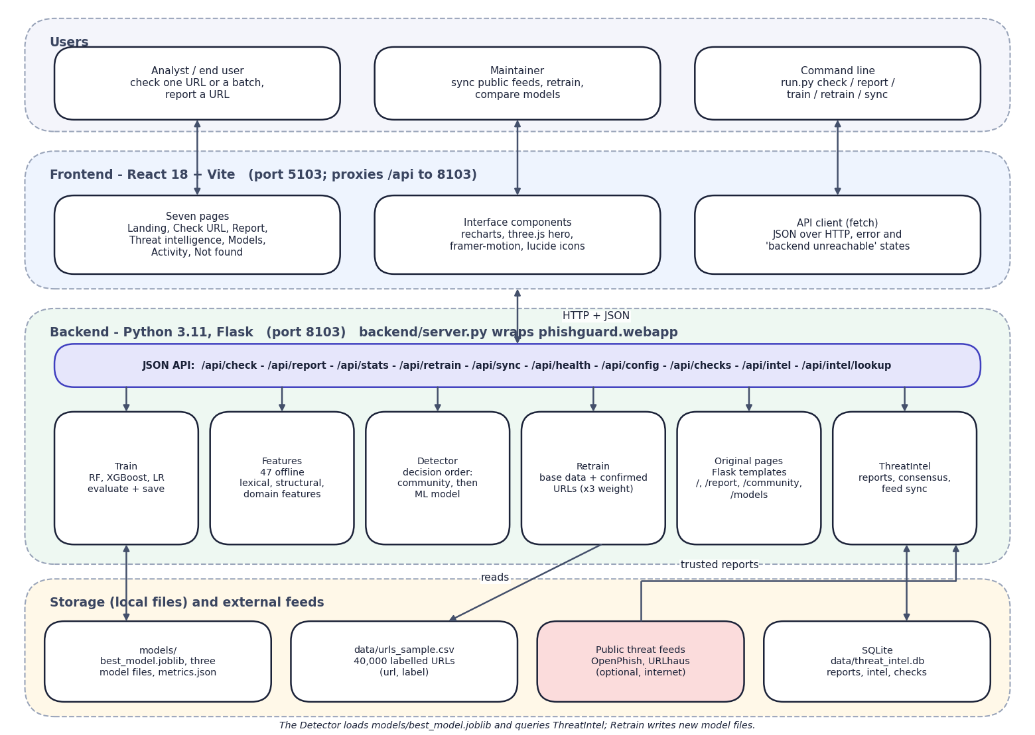
Fig. 5.1: System architecture of PhishGuard
The architecture has four layers. Users reach the system through the React interface on port 5103 or the command line. The Vite dev server serves the seven pages and proxies every /api call to the Flask application on port 8103, so the browser talks to one origin. backend/server.py wraps the original Flask application (phishguard.webapp) without changing it and adds five read-only JSON endpoints and the CORS header.
Behind the API are six modules. Features turns a URL into 47 numbers; Detector applies the decision order; ThreatIntel stores reports and computes consensus; Train fits and compares the models; Retrain merges confirmed URLs into the training data; and the original pages module keeps the first Flask interface alive. Storage is local: the SQLite file threat_intel.db, the model files and metrics.json, and the dataset CSV. The two public feeds are the only external systems, and they are optional.

5.2 High-Level Workflow
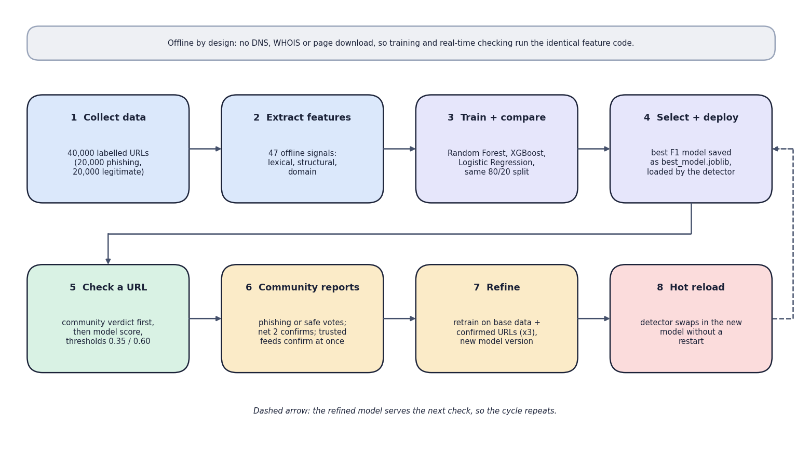
Fig. 5.2: High-level workflow: from dataset to a self-refining detector
The workflow has two halves. In the upper row the system is prepared once: the 40,000-URL dataset is loaded, 47 features are extracted, the three classifiers are trained and compared on the same split, and the best by F1 is saved and loaded by the detector. In the lower row the system is used and improved: a URL is checked, the community reports it, confirmed URLs retrain the models, and the detector hot-reloads the new model. The dashed arrow shows that the refined model serves the next check, so the cycle repeats.
The note at the top records a design choice that makes the loop practical: all features are computed offline from the URL string, so the code that extracts features for training is identical to the code that runs at check time.

5.3 Data-Flow Diagrams
The data-flow diagrams follow the usual levelling: a context diagram, a level-1 decomposition and a level-2 expansion of the check path.
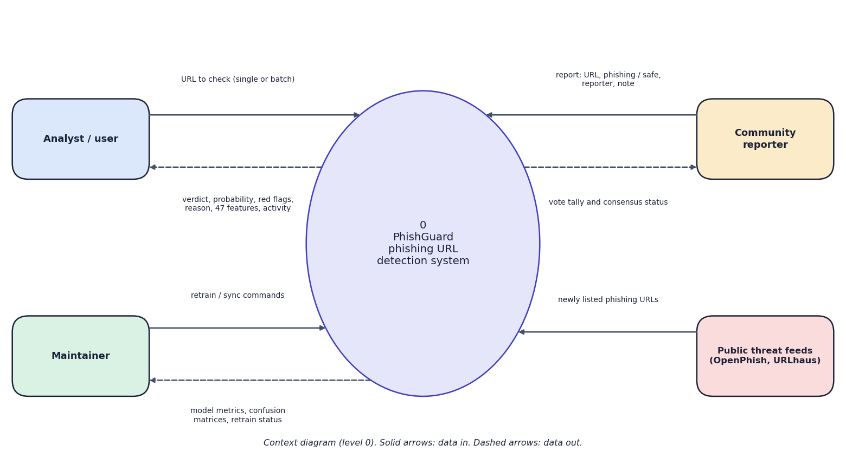
Fig. 5.3: Data-flow diagram, level 0 (context)
The context diagram shows PhishGuard as one process and four external entities. The analyst sends URLs and receives verdicts, probabilities, red flags and the activity log. The community reporter sends reports (URL, phishing or safe, reporter, note) and receives the vote tally and status. The maintainer sends retrain and sync commands and receives metrics and retrain status. The public threat feeds supply newly listed phishing URLs. The analyst and the reporter are often the same person; they are drawn separately because they use different pages.
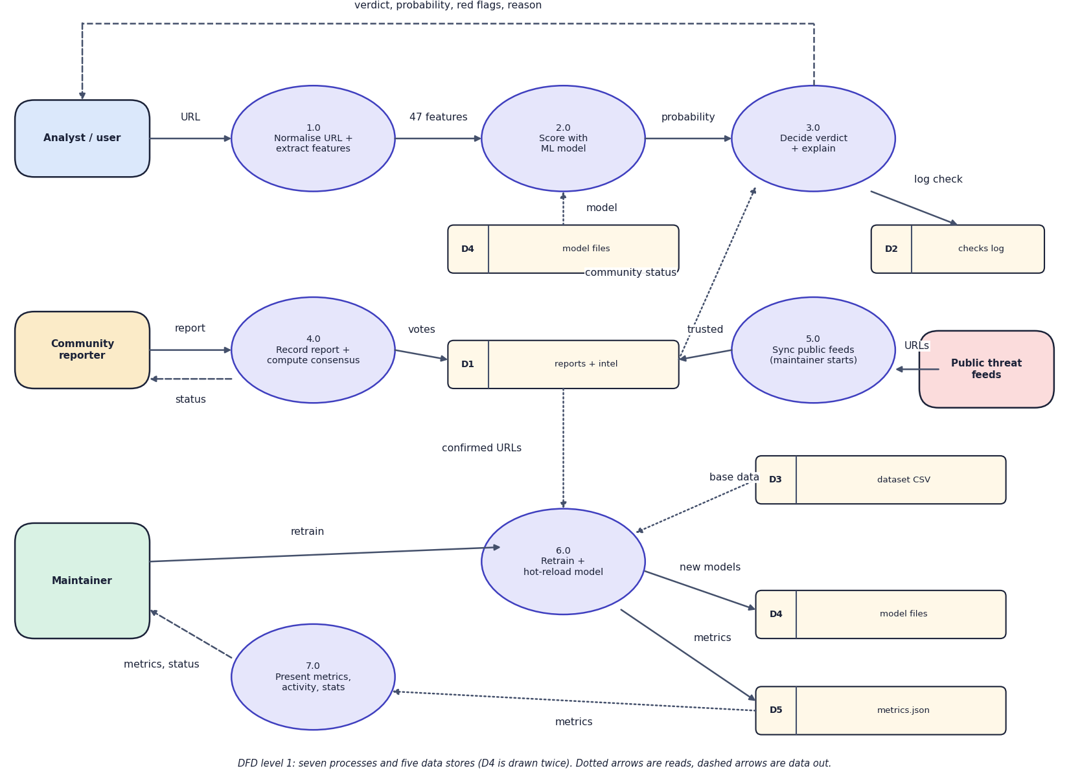
Fig. 5.4: Data-flow diagram, level 1
Level 1 splits the system into seven processes and five data stores. Processes 1.0 to 3.0 form the check path: the URL is normalised and turned into features, scored by the model loaded from D4, and combined with the community status from D1 to give the verdict, which is logged in D2. Process 4.0 records a report and computes consensus in D1. Process 5.0 imports feed URLs as trusted reports. Process 6.0 reads confirmed URLs from D1 and the base data from D3, retrains, and writes new models to D4 and metrics to D5. Process 7.0 presents the metrics, activity and statistics to the maintainer. D4 is drawn twice only to keep the lines short.
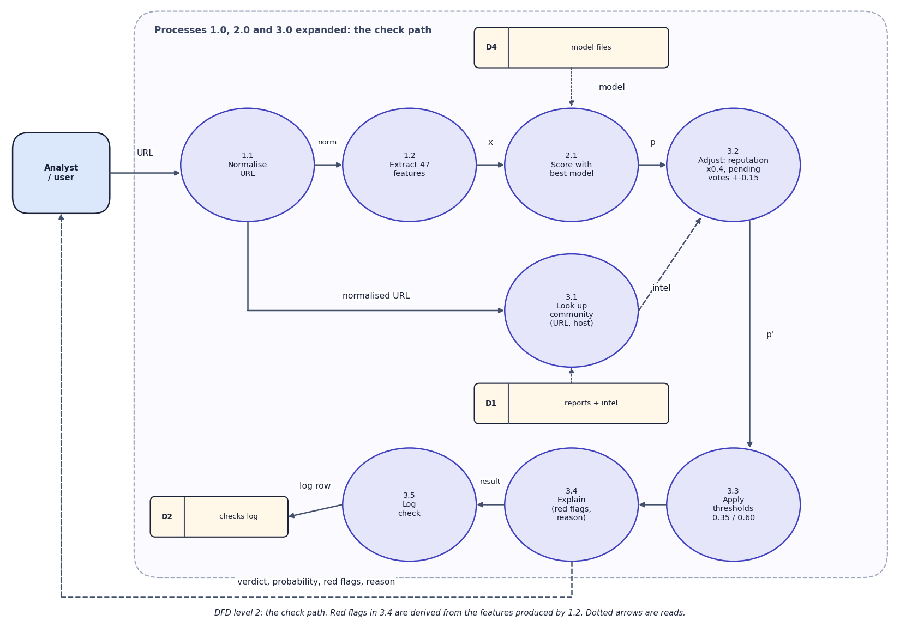
Fig. 5.5: Data-flow diagram, level 2 (the check path)
Level 2 opens the check path. 1.1 normalises the URL (scheme, lower-case host, no www.). 1.2 extracts the 47 features. 2.1 scores them with the best model. 3.1 looks up the community store for the URL and for its host. 3.2 applies the reputation discount (x0.4 for well-known registered domains) and the pending-vote adjustment (+/-0.15 per net vote). 3.3 applies the thresholds 0.35 and 0.60. 3.4 builds the red flags and the reason text from the features. 3.5 writes a row to the checks log. A confirmed community verdict skips 2.1 to 3.3, as the flowchart shows.

5.4 UML Diagrams
Four behavioural and structural diagrams describe the system: use cases, a sequence of the main flow, the class structure and the flowchart of the core algorithm.
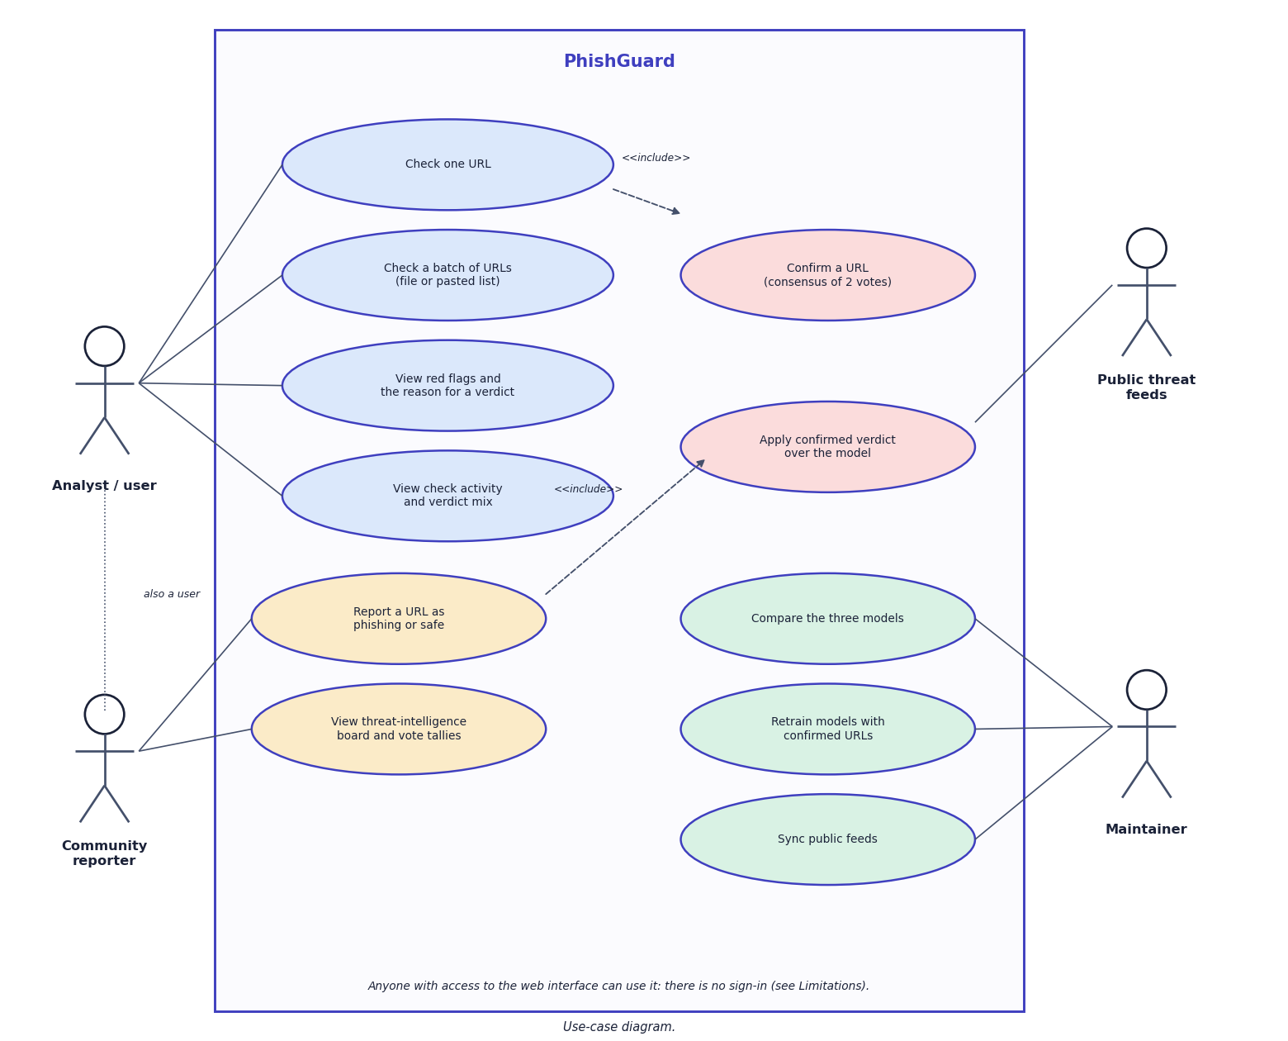
Fig. 5.6: Use-case diagram
The use-case diagram has four actors. The analyst checks a URL or a batch, reads the red flags and the reason, and reviews the activity log. The community reporter reports a URL and views the threat-intelligence board; reporting includes confirmation by consensus. Checking a URL includes applying a confirmed verdict over the model. The maintainer compares the models, retrains them and synchronises the public feeds, and the feeds themselves act on the confirmation use case. The note records that there is no sign-in, so any user can act in any role.
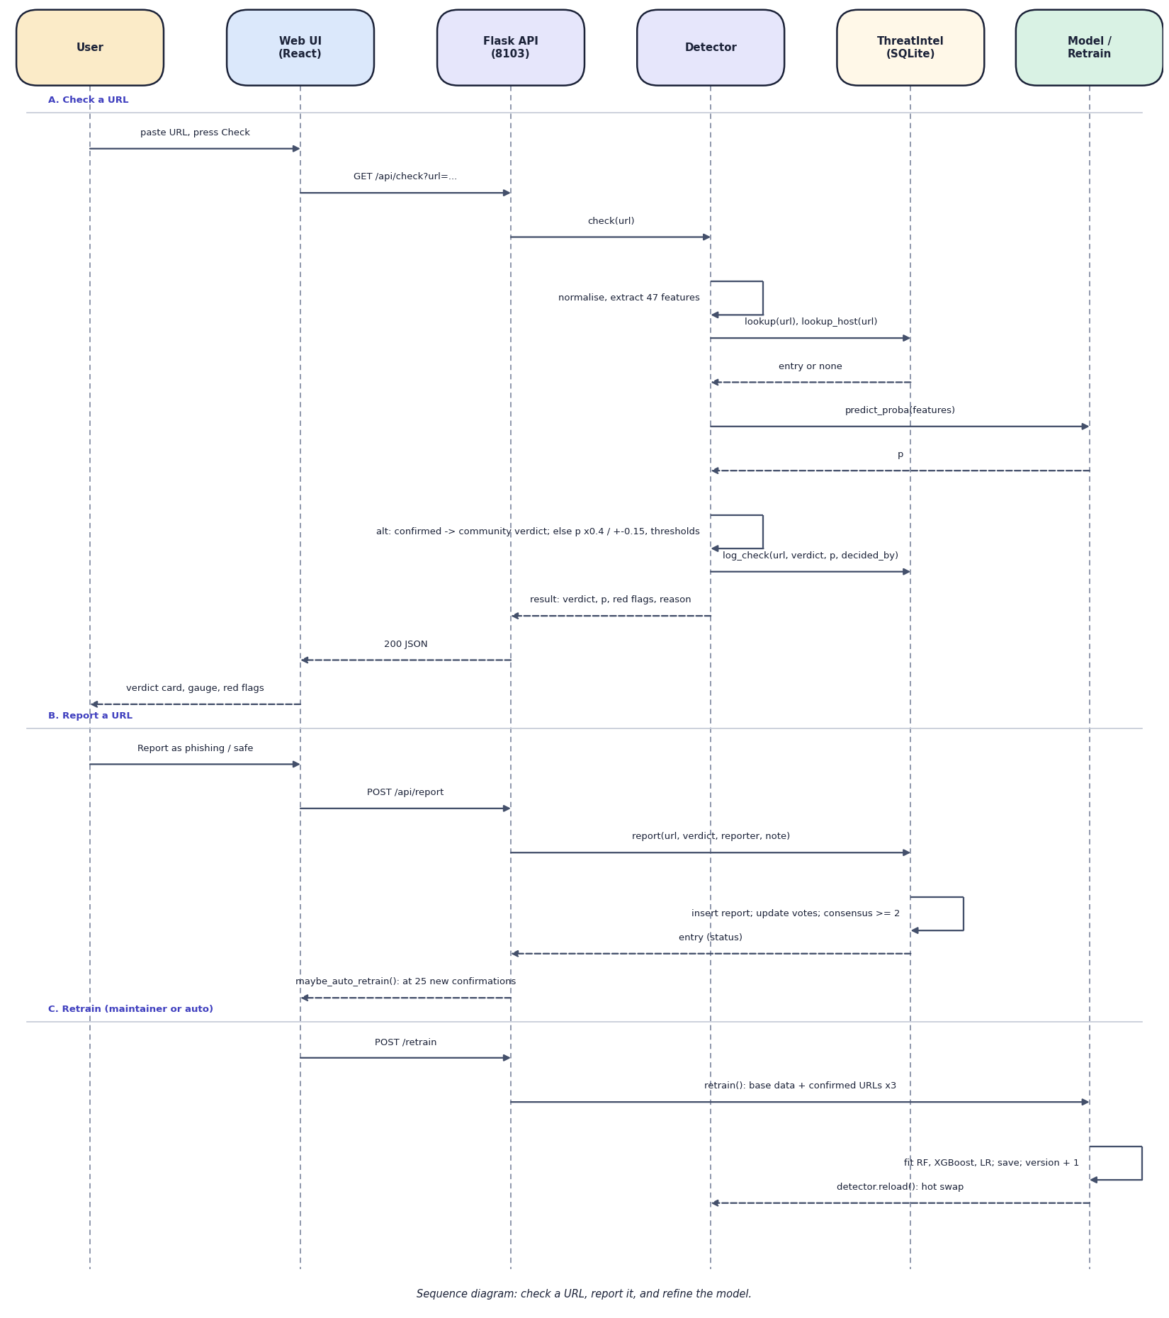
Fig. 5.7: Sequence diagram: check a URL, report it, refine the model
The sequence diagram has three parts. In part A the user presses Check; the React page calls GET /api/check; Flask asks the Detector, which extracts features, queries ThreatIntel for the URL and its host, asks the model for a probability, applies the decision rules, logs the check and returns the result. In part B a report is posted, ThreatIntel inserts it, updates the vote counts and recomputes consensus, and the API may start an automatic retrain after 25 new confirmations. In part C a retrain fits the three models, bumps the version and tells the Detector to reload the best model.
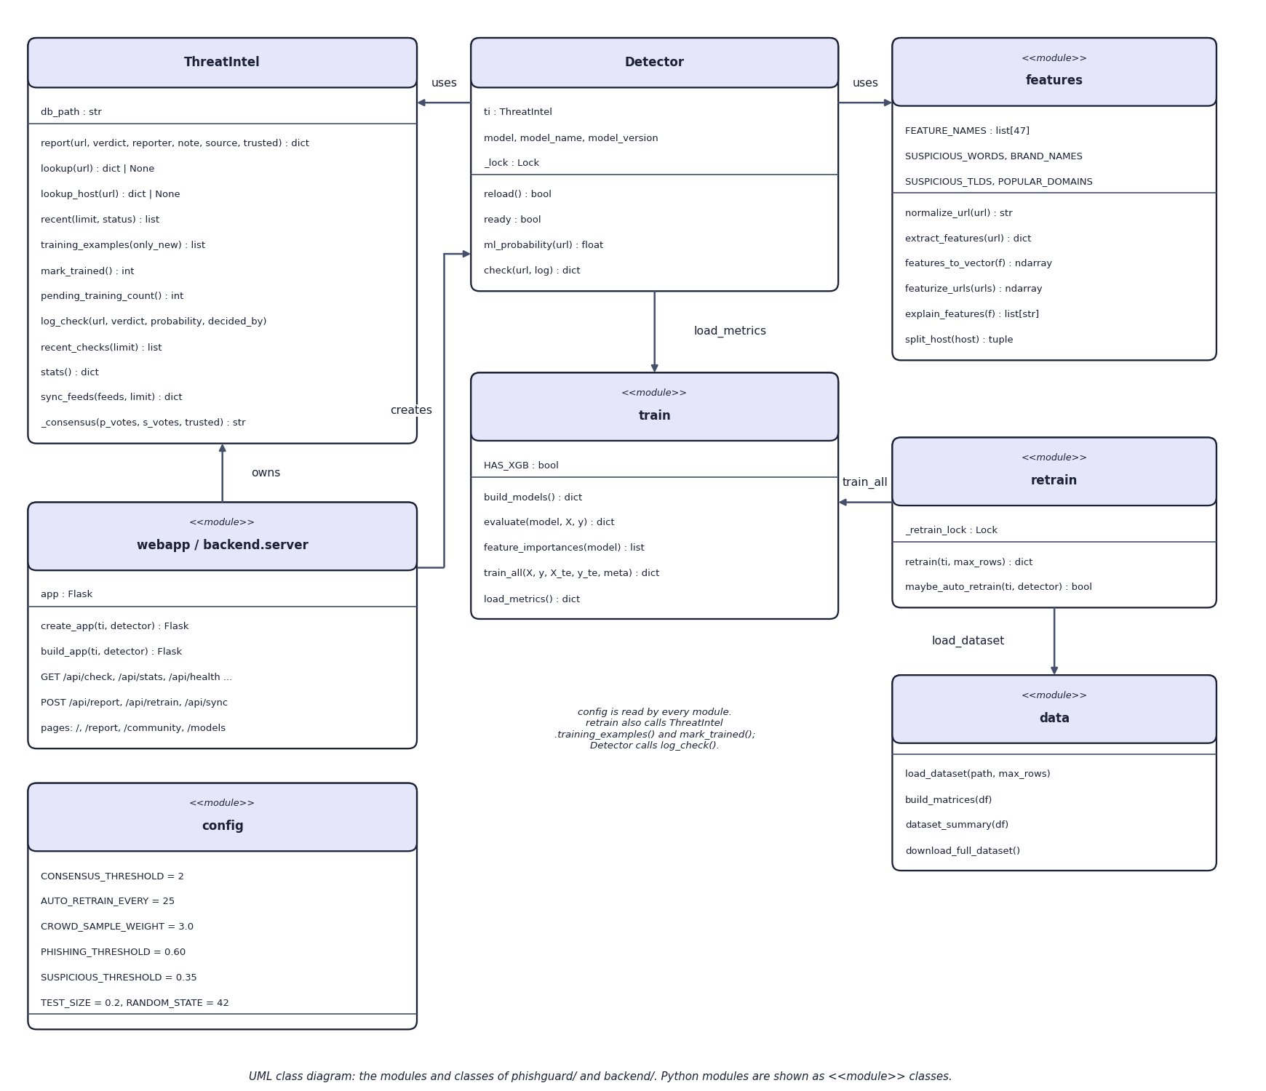
Fig. 5.8: UML class diagram of the Python modules
The class diagram shows the Python structure. ThreatIntel is the only real class with state (the database path). Detector holds a ThreatIntel, the loaded model, its name and version, and a lock that protects the model while it is swapped. features, train, retrain, data and config are modules of functions and constants, drawn as <<module>> classes. webapp and backend.server create the Flask application and call Detector.check. retrain calls train_all and load_dataset, and uses ThreatIntel's training_examples and mark_trained.
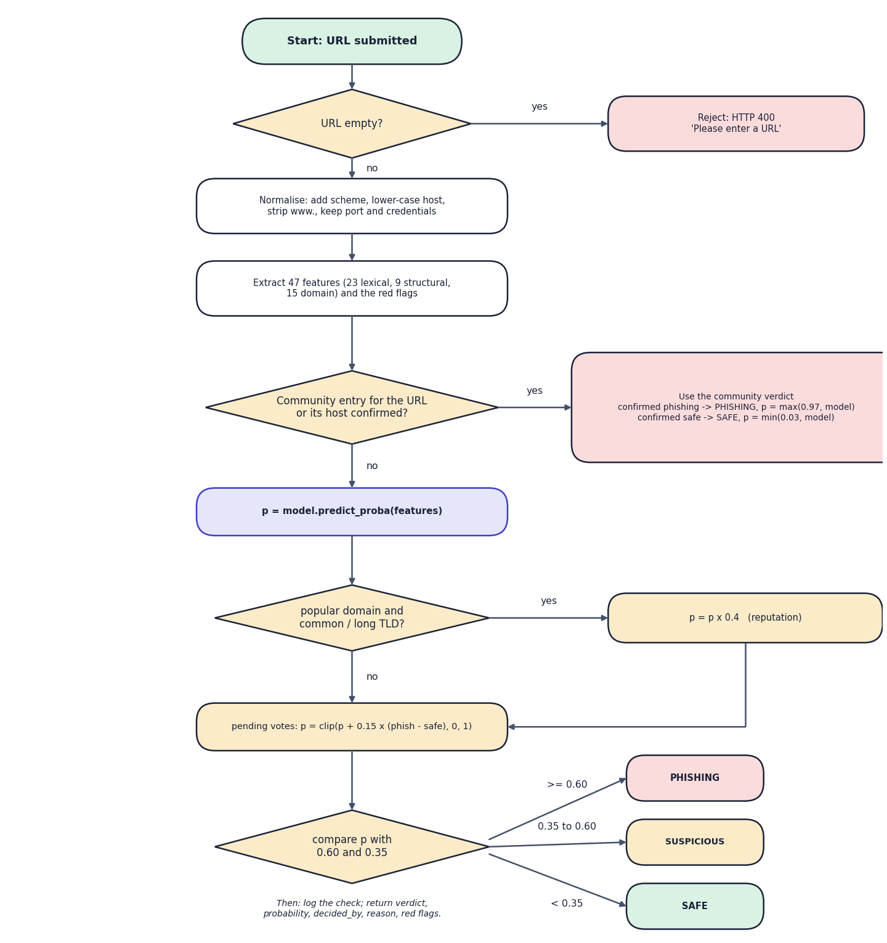
Fig. 5.9: Flowchart of the core algorithm (decision order of detector.check)
The flowchart is the decision procedure of Detector.check. An empty URL is rejected with HTTP 400. Otherwise the URL is normalised, 47 features and the red flags are extracted, and the community store is queried for the URL and for its host. A confirmed community entry decides at once: confirmed phishing gives probability max(0.97, model) and confirmed safe gives min(0.03, model). Otherwise the model produces p; a well-known registered domain multiplies p by 0.4; pending votes add 0.15 per net vote; and p is compared with 0.60 (phishing) and 0.35 (suspicious). Every outcome is logged and returned with its reason.

5.5 Database Design
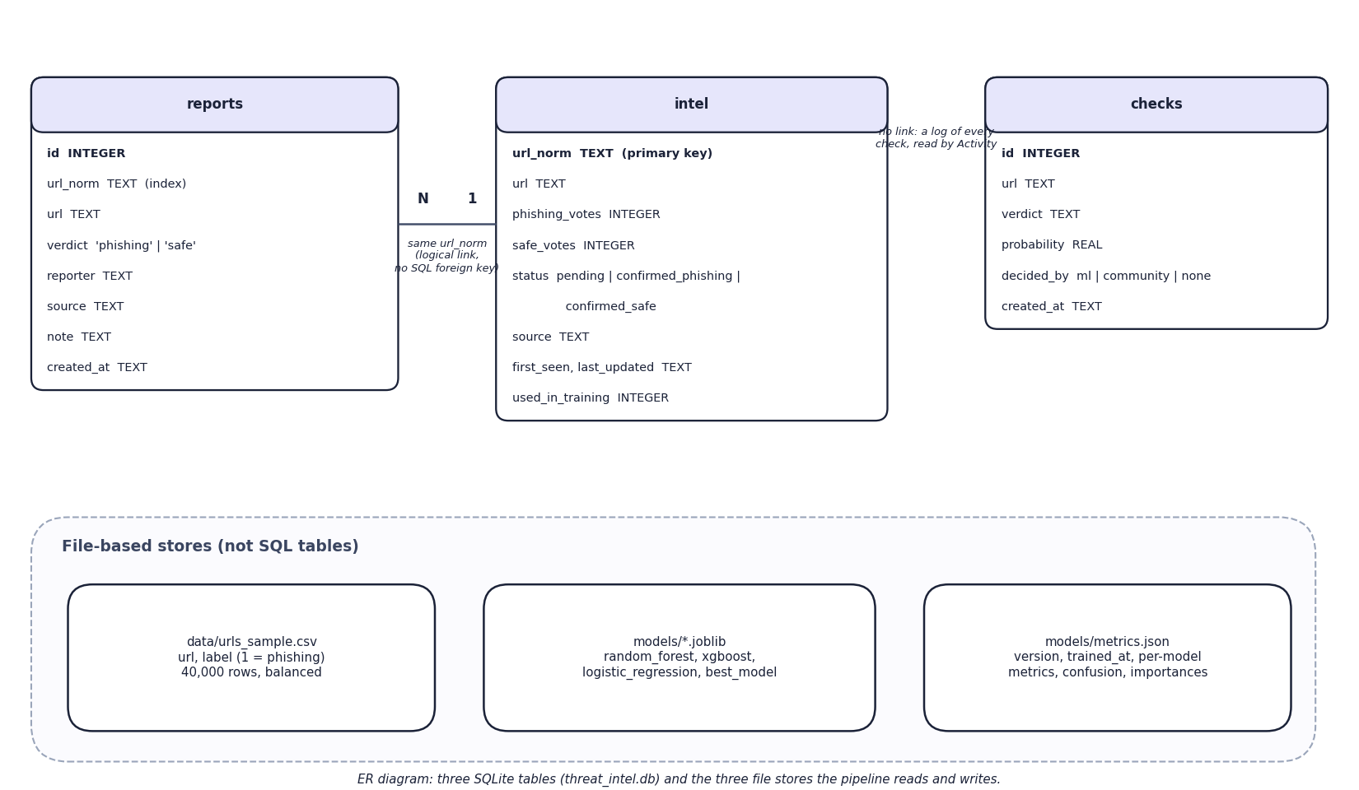
Fig. 5.10: Entity-relationship diagram
The database has three tables in threat_intel.db. reports stores every individual report (URL, verdict, reporter, source, note, time) and is indexed on the normalised URL. intel holds one row per normalised URL with its phishing and safe vote counts, its status (pending, confirmed_phishing or confirmed_safe), its source, first-seen and last-updated times and a flag showing whether it has been used in training. checks is an append-only log of every verdict. reports and intel are linked logically by the normalised URL; the schema declares no SQL foreign key. The lower panel shows the three file-based stores that the pipeline reads and writes.
Table 5.1: Schema of the SQLite database (phishguard/threat_intel.py)
Table | Column | Type | Notes
reports | id | INTEGER | primary key, autoincrement
 | url_norm, url | TEXT | normalised and original URL; index idx_reports_url on url_norm
 | verdict | TEXT | CHECK in ('phishing', 'safe')
 | reporter, source, note | TEXT | defaults: 'anonymous', 'community'
 | created_at | TEXT | UTC ISO time
intel | url_norm | TEXT | primary key
 | url | TEXT | first original form
 | phishing_votes, safe_votes | INTEGER | default 0
 | status | TEXT | pending | confirmed_phishing | confirmed_safe
 | source, first_seen, last_updated | TEXT | source is community or the feed name
 | used_in_training | INTEGER | 1 after a retrain has consumed the entry
checks | id, url, verdict, probability, decided_by, created_at | INTEGER, TEXT, REAL | append-only activity log

Each connection is opened per operation with a 30-second timeout and committed on exit, so the Flask worker threads and the background retrain thread do not share a connection. All statements use bound parameters.

5.6 Module Design
Table 5.2: Module breakdown
Module | File | Responsibility | Main functions
Features | phishguard/features.py | URL normalisation, 47 features, red flags | normalize_url, extract_features, featurize_urls, explain_features
Data | phishguard/data.py | Load, clean and split the dataset | load_dataset, build_matrices, dataset_summary
Train | phishguard/train.py | Fit, evaluate and save three models; metrics.json | build_models, evaluate, train_all, load_metrics
ThreatIntel | phishguard/threat_intel.py | Reports, votes, consensus, feed sync, check log | report, lookup, lookup_host, sync_feeds, stats
Detector | phishguard/detector.py | Decision order and hot reload | check, ml_probability, reload
Retrain | phishguard/retrain.py | Merge confirmed URLs and retrain | retrain, maybe_auto_retrain
Web app | phishguard/webapp.py | Original Flask pages and the JSON API | create_app
API layer | backend/server.py | Adds five read-only endpoints and CORS; port 8103 | build_app
CLI | run.py | train, check, report, sync, retrain, serve, download | cmd_*
Frontend | frontend/src | Seven pages, components, API client | pages/*.jsx, lib/api.js

5.7 User Interface Design
The interface is a React single-page application with a landing page and a six-item side navigation (Check URL, Report, Threat intelligence, Models, Activity, Landing page). Colour carries meaning consistently: red for phishing, amber for suspicious, green for safe. Every result shows a probability gauge and a risk scale with the two thresholds marked, so the user sees how close a verdict is to the boundary. A light and a dark theme are available.

Fig. 5.11: Check URL screen: verdict, probability gauge and risk scale

Fig. 5.12: Models screen: comparison, confusion matrix and feature importances
- Check URL. Single and batch tabs; example URLs; verdict card; red flags; community status; the 47 extracted features; recent checks.
- Report. URL, phishing or safe, reporter name and note, with the consensus rule explained beside the form.
- Threat intelligence. Counters, a searchable table with status and vote columns, a detail drawer and a feed-sync dialog.
- Models. Metric cards, bar and radar charts, comparison table, confusion matrix, top-10 feature importances and the retrain control.
- Activity. Check log with a probability trend, verdict mix and search.
- States. Loading skeletons, empty states and a clear message when the backend is unreachable.

CHAPTER 6
METHODOLOGY AND SOFTWARE IMPLEMENTATION

6.1 Overall Methodology
The methodology implements the three phases of the base paper [1] as one pipeline. Phase 1 turns a URL into numbers; phase 2 classifies; phase 3 collects community evidence and refines the classifier. The pipeline is used in two modes: an offline mode that prepares the models, and an online mode that answers requests and learns.
Table 6.1: End-to-end pipeline
Step | Stage | What happens | Code
1 | Data collection | 40,000 labelled URLs (20,000 phishing, 20,000 legitimate) are read from a CSV file | data.load_dataset
2 | Cleaning | Missing values dropped, labels mapped to 0/1, URLs trimmed and de-duplicated | data.load_dataset
3 | Feature extraction | Each URL becomes a vector of 47 lexical, structural and domain features | features.featurize_urls
4 | Split | Stratified 80/20 split with a fixed seed: 32,000 train, 8,000 test | data.build_matrices
5 | Training | Random Forest, XGBoost and Logistic Regression are fitted on the same training data | train.train_all
6 | Evaluation | Accuracy, precision, recall, F1, ROC-AUC, FPR and confusion matrix on the test set | train.evaluate
7 | Selection | The model with the highest F1 (ROC-AUC breaks ties) is saved as best_model.joblib | train.train_all
8 | Real-time check | Community verdict first; otherwise model score with adjustments and thresholds | detector.check
9 | Crowd feedback | Users report URLs; votes are counted; trusted feeds confirm immediately | threat_intel.report
10 | Refinement | Confirmed URLs join the training data (x3) and all models are retrained; the detector reloads | retrain.retrain

6.2 Dataset
The training data is data/urls_sample.csv, a balanced sample of 40,000 URLs taken from the public "Using machine learning to detect malicious URLs" dataset of about 420,000 labelled URLs [25]. The sampling is described in the code (phishguard/data.py); the original dataset's licence is not stated in the repository and was not verified, and the project does not redistribute anything beyond this sample. The full file can be fetched with python run.py download; it was not used or evaluated.
Table 6.2: Dataset facts
Property | Value
Rows | 40,000 (20,000 phishing, 20,000 legitimate)
Unique URLs | 40,000
URL length (characters) | mean 51.5, median 40, maximum 1,383
Mean length by class | phishing 55.9, legitimate 47.1
URLs that contain a scheme | 266 of 40,000 (the rest are scheme-less, e.g. host/path)
File size | 2,181,263 bytes
Split | 80 % train (32,000) / 20 % test (8,000), stratified, random_state 42; test set 4,000 + 4,000
Not used | Page content, WHOIS, DNS, certificates, screenshots

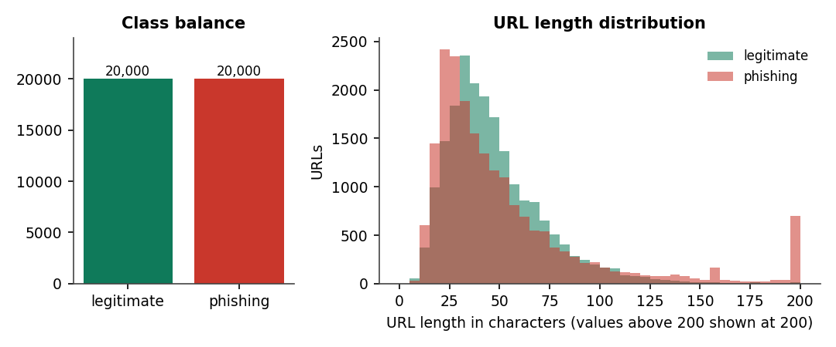
Fig. 6.1: Class balance and URL length distribution of the training data
Two properties of the data matter later. The classes are balanced, so accuracy is meaningful and no resampling is needed. And most URLs have no scheme, so the extractor normalises each URL by prepending http:// before any feature is computed; the feature has_https_in_path_or_host therefore reflects the word "https" inside the host or path, not the scheme.

6.3 Data Preprocessing and Feature Extraction

6.3.1 Cleaning
load_dataset reads the CSV, skips malformed lines, drops rows with a missing URL or label, maps text labels (bad, phishing, malicious to 1; good, benign, legitimate to 0), trims whitespace, removes URLs shorter than four characters and drops duplicate URLs. No imputation or scaling is applied to the data; Logistic Regression receives a StandardScaler inside its pipeline.

6.3.2 Normalisation
normalize_url makes the extraction deterministic: it trims the string, replaces spaces by %20, adds http:// when no scheme is present, lower-cases the scheme and host, strips a leading www., and keeps the port, credentials, path, query and fragment. A malformed port or an unmatched bracket never raises: the splitter falls back to a cleaned form, and as a last resort to a placeholder host. This is why 17 validation checks, including a malformed port and a 5,000-character URL, all return a normal response.

6.3.3 The 47 features
Features are computed from the URL string alone and are grouped as the project objectives describe: lexical features describe the characters, structural features describe how the URL is built, and domain features describe the registered domain and its top-level domain. Nothing needs the network.
Table 6.3: Lexical (23) features
Features | Meaning
url_length, host_length, path_length, query_length, fragment_length | Lengths of the whole URL and of its parts
num_dots, num_hyphens, num_underscores, num_slashes, num_equals, num_ampersands, num_percent | Counts of separator and special characters
num_digits, digit_ratio, letter_ratio | Digits and letters in the URL and their share
num_special_chars, has_at_symbol, has_encoded_chars | Special characters, '@' (browsers ignore text before it), percent-encoding
num_query_params | Number of query parameters
url_entropy | Shannon entropy of the lower-cased URL
suspicious_word_count | Occurrences of 42 credential-related words (login, verify, secure, bank ...)
longest_token_length | Longest alphanumeric token
has_https_in_path_or_host | The word 'https' used inside the host or path

Table 6.4: Structural (9) features
Features | Meaning
is_ip_host | Host is an IP address (dotted, hexadecimal or decimal)
has_port, nonstandard_port | Explicit port; port other than 80 or 443
num_subdomains | Number of sub-domain labels
path_depth, has_double_slash_in_path | Path segments; '//' inside the path
is_url_shortener | Host is one of 20 known shorteners
has_file_extension, has_executable_extension | File extension in the path; .exe, .apk, .zip and similar

Table 6.5: Domain (15) features
Features | Meaning
domain_length, domain_digit_count, domain_hyphen_count | Registered-domain length, digits and hyphens
domain_entropy, domain_vowel_ratio, domain_max_consonant_run | Randomness of the domain name (generated names look unpronounceable)
tld_length, is_suspicious_tld, is_common_tld | Top-level domain length; in a list of 41 abused TLDs; in com/org/net/edu/gov/mil/int
brand_in_domain, brand_outside_domain | A well-known brand name in the registered domain, or in the sub-domain, path or query
subdomain_length, subdomain_has_digit, tld_in_subdomain | Sub-domain length and digits; a 'com' or 'net' token inside the sub-domain
is_popular_domain | Registered domain is in a built-in list of 145 popular sites (domain reputation)

6.3.4 Red flags
explain_features turns the numbers into at most 16 plain sentences, for example "Host is a raw IP address instead of a domain name", "Registered domain imitates a well-known brand but is not the official site" or "Top-level domain is frequently abused by phishing campaigns". The red flags are shown beside every verdict.

6.4 Algorithm Choice and Justification
Three classifiers were chosen because the project objectives name them, they cover three model families, and all train in seconds on the feature matrix.
Table 6.6: Classifiers and settings
Model | Family | Why it was included | Settings (phishguard/train.py)
Logistic Regression | Linear | Interpretable baseline; the base paper's related work uses it with mutual-information features [6] | StandardScaler + LogisticRegression, C 1.0, max_iter 2000, class_weight balanced
Random Forest [21] | Bagged trees | Robust to feature scale, gives importances, strong on tabular data | 300 trees, unlimited depth, class_weight balanced, n_jobs -1, random_state 42
XGBoost [22] | Boosted trees | Usually the strongest tabular learner; fast | 400 trees, max_depth 8, learning rate 0.08, subsample 0.9, colsample 0.9, logloss, random_state 42

The deployed model is the one with the highest F1 on the test set; ROC-AUC breaks a tie. In the shipped run this is XGBoost (F1 92.88 %), followed closely by Random Forest (92.47 %); Logistic Regression is clearly behind (81.80 %), which shows that a linear boundary over these features is not enough. The deep LSTM-attention network of the base paper was not reproduced: it needs the URL text and page features of a much larger dataset, and tree ensembles on engineered features are lighter, train in seconds and can explain their decisions.
No hyper-parameter search was run. The settings are common defaults, chosen once; the 5-fold cross-validation below shows that the results are stable, but a tuned model could score higher.

6.5 Mathematical Formulation
Shannon entropy of a string s with character frequencies p(c), used for url_entropy and domain_entropy [24]:
H(s) = - sum over characters c of p(c) log2 p(c)
Logistic regression models the phishing probability of a feature vector x as P(y = 1 | x) = 1 / (1 + exp(-(w.x + b))), with the weights w fitted by regularised maximum likelihood (C = 1.0). Random Forest averages the class probabilities of 300 decision trees grown on bootstrap samples [21]. XGBoost adds 400 regression trees, each fitted to the gradient of the logistic loss, with a learning rate of 0.08 [22]; the probability is the logistic function of the summed tree outputs.
Evaluation metrics, with TP, TN, FP and FN counted on the 8,000 test URLs:
accuracy = (TP + TN) / (TP + TN + FP + FN); precision = TP / (TP + FP); recall = TP / (TP + FN); F1 = 2 x precision x recall / (precision + recall); FPR = FP / (FP + TN).
ROC-AUC is the area under the curve of recall against FPR as the probability threshold varies.
Consensus rule. For a URL with a phishing votes and b safe votes, let n = a - b. The status is confirmed_phishing if n >= 2 or if the report comes from a trusted feed; confirmed_safe if n <= -2; otherwise pending. The constant 2 is CONSENSUS_THRESHOLD.
Decision rule. With the model probability p, the reputation factor r = 0.4 if the registered domain is popular and its TLD is common or longer than two letters (otherwise 1), and the net pending votes n:
p' = clip(r x p + 0.15 x n, 0, 1); verdict = phishing if p' >= 0.60, suspicious if p' >= 0.35, otherwise safe.
When a confirmed entry exists, the verdict is fixed (phishing with probability max(0.97, p), or safe with min(0.03, p)). The reputation discount is applied only when no community verdict exists, and the vote nudge applies to unconfirmed entries.
Retraining weights. Each confirmed URL is repeated round(3.0) = 3 times in the training matrix, so it counts three times in the fit; base-data rows that the crowd has re-labelled are removed first.

6.6 Model Training and Evaluation
Table 6.7: Training configuration and cost
Property | Value
Training rows / test rows | 32,000 / 8,000
Features | 47
Model version / trained | 1 / 2026-09-22T07:13:23+00:00
Training time | Random Forest 12.2 s, XGBoost 2.7 s, Logistic Regression 0.2 s
Feature extraction for 40,000 URLs | 4.0 s
Saved files | random_forest.joblib 165 MB, xgboost.joblib 2.5 MB, logistic_regression.joblib 2.8 KB, best_model.joblib 2.5 MB, metrics.json

train_all fits each model, evaluates it on the test set, stores the metrics, the confusion matrix and the top-15 feature importances, and writes models/metrics.json with an incremented version number. The shipped numbers were reproduced for this report: re-scoring the saved Random Forest and XGBoost files on the same split gives exactly the values in metrics.json, and the logistic-regression file, which cannot be loaded under the installed scikit-learn, was refitted and matched as well.
The results of the evaluation are presented in Chapter 8. The retraining loop is described in the next sections.

6.7 Application Architecture
The application is a Flask app created by create_app(ti, detector). backend/server.py calls it unchanged, adds five read-only endpoints (/api/health, /api/config, /api/checks, /api/intel, /api/intel/lookup) and a CORS header, and serves on port 8103. The React frontend on port 5103 proxies /api and /retrain to it, so the browser makes only same-origin requests.
- Concurrency. Flask runs threaded. SQLite connections are opened per call. Model access is guarded by a lock, and a retrain lock makes a second concurrent retrain return "a retrain is already running".
- Hot reload. After a retrain, Detector.reload() loads best_model.joblib under the lock, so requests in flight use either the old or the new model, never a mix.
- Background retraining. The form route /retrain and automatic retraining start a daemon thread; /api/retrain is blocking. The interface polls /api/stats for the retraining flag every three seconds.
- State on disk. The community store, the model files and metrics.json are the only state; the application itself is stateless between requests.

6.8 Key Code Walkthroughs

6.8.1 Consensus: when does a URL become confirmed
The status machine is a small pure function. Two net phishing votes, or a trusted feed, confirm phishing; two net safe votes confirm legitimate; anything else stays pending.
Listing: ThreatIntel._consensus
def _consensus(p_votes: int, s_votes: int, trusted: bool = False) -> str:
net = p_votes - s_votes
if trusted or net >= config.CONSENSUS_THRESHOLD:
return "confirmed_phishing"
if -net >= config.CONSENSUS_THRESHOLD:
return "confirmed_safe"
return "pending"

6.8.2 Retraining: weighting and hot reload
Confirmed URLs replace any base-data rows they re-label, are repeated three times, and are split with the same stratified seed.
Listing: retrain.retrain (excerpt)
crowd = ti.training_examples()
crowd_df = pd.DataFrame(crowd, columns=["url", "label"]).astype({"url": str, "label": int})
if verbose:
print(f"Base dataset: {len(base)} rows | crowdsourced confirmed: {len(crowd_df)} rows")

# remove base rows that the crowd has since re-labelled
if len(crowd_df):
base = base[~base["url"].isin(crowd_df["url"])]
full = pd.concat([base, crowd_df], ignore_index=True)
weights = np.concatenate([
np.ones(len(base)), np.full(len(crowd_df), config.CROWD_SAMPLE_WEIGHT)])

X = featurize_urls(full["url"].tolist())
y = full["label"].astype(int).to_numpy()
X_tr, X_te, y_tr, y_te, w_tr, _ = train_test_split(
X, y, weights, test_size=config.TEST_SIZE,
random_state=config.RANDOM_STATE, stratify=y)

# sample weights are passed by duplicating weighted rows (works for every model)
reps = np.round(w_tr).astype(int)
X_tr = np.repeat(X_tr, reps, axis=0)
y_tr = np.repeat(y_tr, reps, axis=0)

6.8.3 Decision order in the detector
The decision order is the heart of the system: community first, then the model, then adjustments and thresholds (see the flowchart in Chapter 5).
Listing: Detector.check (excerpt)
# 1. crowdsourced intelligence
intel = self.ti.lookup(url_norm) or self.ti.lookup_host(url_norm)
ml_prob = self.ml_probability(url_norm) if self.ready else None
result["ml_probability"] = None if ml_prob is None else round(ml_prob, 4)
result["community"] = None
if intel:
result["community"] = {
"status": intel["status"],
"phishing_votes": intel["phishing_votes"],
"safe_votes": intel["safe_votes"],
"source": intel["source"],
"last_updated": intel["last_updated"],
}
if intel and intel["status"] == "confirmed_phishing":
result.update(verdict="phishing", probability=max(0.97, ml_prob or 0),
decided_by="community", reason=(
f"Confirmed phishing by crowdsourced threat intelligence "
f"({intel['phishing_votes']} phishing vs {intel['safe_votes']} safe "
f"reports, source: {intel['source']})."))
elif intel and intel["status"] == "confirmed_safe":
result.update(verdict="safe", probability=min(0.03, ml_prob or 0),
decided_by="community",
reason="Confirmed legitimate by community consensus.")
elif ml_prob is None:
result.update(verdict="unknown", probability=None, decided_by="none",
reason="No trained model found - run `python run.py train` first.")
else:
# 2./3. ML with soft community evidence
prob = ml_prob
reputable = feats["is_popular_domain"] and (feats["is_common_tld"] or feats["tld_length"] > 2)
if reputable: # domain-reputation adjustment for well-known registered domains
prob *= 0.4
if intel:
net = intel["phishing_votes"] - intel["safe_votes"]
prob = float(np.clip(prob + 0.15 * net, 0.0, 1.0))
if prob >= config.PHISHING_THRESHOLD:
verdict = "phishing"
elif prob >= config.SUSPICIOUS_THRESHOLD:

6.9 Implementation Decisions and Reasoning
Table 6.8: Main implementation decisions
Decision | Reasoning | Consequence
Offline URL-only features | Training and run time must use identical code; fetching pages is slow and risky | Fast and safe; cannot see page content
Three classical models, not a deep network | Objective 3 names them; they train in seconds and give importances | Lower accuracy than the base paper's network
Same split and features for every model | A fair comparison needs identical data | Differences reflect the algorithm only
Select by F1, break ties by ROC-AUC | Classes are balanced; F1 balances missed phishing and false alarms | XGBoost selected
Community verdict before the model | A confirmed human verdict is stronger evidence than a score; it gives zero-day coverage at once | Wrong consensus overrides a right model
Net votes of 2 for confirmation | Simple, explainable, quick; one report is not enough | Two cooperating reporters can confirm anything
Confirmed-safe status | The community must be able to undo false positives (problem statement point 4) | Not in the base paper
Host-level lookup | A confirmed phishing host usually serves many pages | Over-blocks shared hosts
Reputation discount x0.4 for popular domains | Cuts false alarms on well-known sites cheaply | Hand-written list; misses amazon.in and docs.python.org
Retrain weight 3 by row repetition | Works with every model without special sample-weight support | Memory grows with weight
Hot reload under a lock | Avoid restarts and torn reads of the model | In-flight requests use old or new model, never a mix
Keep the original Flask app and add an API layer | Preserves the tested pages and CLI; the new UI needs only a thin, additive layer | Two interfaces to maintain
SQLite | Single file, no server, enough for a local deployment | Not for heavy concurrent writes

6.10 API Design
Table 6.9: JSON API (port 8103)
Method | Path | Request | Response
GET | /api/check?url= | query url | verdict, probability, ml_probability, decided_by, reason, red_flags[], features{47}, model, model_version, community; 400 {error} for an empty URL
POST | /api/report | JSON url, verdict, reporter, note | the intel entry (votes, status, source, times); 400 for a bad verdict or URL
GET | /api/stats | - | threat_intel counters, metrics.json, retraining flag
POST | /api/retrain | - | blocking retrain; the new metrics summary
POST | /api/sync | - | per-feed result {ok, added} or {ok: false, error}
GET | /api/health | - | ok, model_ready, model, model_version
GET | /api/config | - | thresholds, consensus and retrain constants, feature names by group
GET | /api/checks?limit= | limit (1-500) | recent checks
GET | /api/intel?limit=&status= | optional filters | intel entries; 400 for an unknown status
GET | /api/intel/lookup?url= | query url | one entry with its last 10 reports; 400 for no URL

An example response of GET /api/check?url=http://secure-paypal-login.account-verify.tk/signin?user=a (abridged):
Listing: Abridged JSON response
{"verdict": "phishing", "probability": 0.9989, "decided_by": "ml", "model": "xgboost", "model_version": 1,
"reason": "Xgboost estimates a 99.9% phishing probability from 47 lexical, structural and domain features.",
"red_flags": ["Registered domain imitates a well-known brand but is not the official site", "..."],
"community": null, "features": {"url_length": 54, "suspicious_word_count": 4, "...": "..."}}

6.11 Security and Error Handling
- The URL is never fetched. The system only reads the string, so a malicious URL cannot execute anything or make the server contact it.
- Parameterised SQL. Every statement binds its values; a SQL-injection string in a URL or reporter name is stored as plain data (tested).
- Output escaping. The Flask pages use Jinja auto-escaping and React escapes by default; script tags in reported URLs, notes and names are not executed (tested).
- Input validation. An empty or whitespace-only URL, an unknown verdict and an unknown status each return HTTP 400 with a JSON error.
- Bounded work. Batch checks are limited to 100 URLs in the interface; feed synchronisation adds at most 500 URLs per feed and has a 20-second timeout.
- Failure isolation. A failing feed is reported per feed and never stops the application; the interface shows a clear message if the backend is unreachable.
- Secrets. The application needs none. The .env file holds only ports (and an unrelated API key that PhishGuard does not read).
- Known weaknesses. No authentication, CORS *, anonymous reports, no rate limit, and feed URLs accepted without verification. These are listed as limitations.

6.12 Installation and Execution
Windows, one command. From 8.ProjectCode, run.bat trains the models if models/best_model.joblib is missing, installs the frontend dependencies on first run, opens the API (port 8103) and the interface (port 5103) in two windows and launches the browser.
Listing: Manual start
pip install -r requirements.txt
python run.py train # under a minute: features + three models
python backend/server.py # API on http://127.0.0.1:8103
cd frontend && npm install && npm run dev # UI on http://localhost:5103

Table 6.10: Command-line interface
Command | Purpose
python run.py train | Train and compare the three models; write models/ and metrics.json
python run.py check <url> | Classify from the terminal
python run.py report <url> phishing|safe --reporter NAME | File a community report
python run.py sync | Import OpenPhish and URLhaus URLs (needs internet)
python run.py retrain | Retrain with confirmed URLs
python run.py serve | Original Flask interface on port 5000
python run.py download | Fetch the full dataset (not used in this report)
python tests.py; python scripts/smoke_test.py; python scripts/extra_tests.py | Run the automated checks

CHAPTER 7
SYSTEM TESTING

7.1 Testing Strategy
Testing combines three sets of automated checks, all run on 15 October 2026 with no failures, and a manual walkthrough of the interface. The checks use a throw-away SQLite database and never retrain, so the shipped data and models are untouched.
Table 7.1: Test suites
Suite | Run with | Size | Result
Original unit and web tests | python tests.py | 3 test functions (features, threat intelligence, web app and API) | All passed
End-to-end API smoke test | python scripts/smoke_test.py | 20 checks over the API used by the React interface | All passed
Extended suite (added for this report) | python scripts/extra_tests.py | 72 checks in six categories | 72 of 72 passed
Interface walkthrough | Playwright with Chrome | 24 captured screens, batch, report, sync and retrain flows | Completed; screens in Chapter 8

In total 95 automated checks were executed. The extended suite is organised by category, shown below.
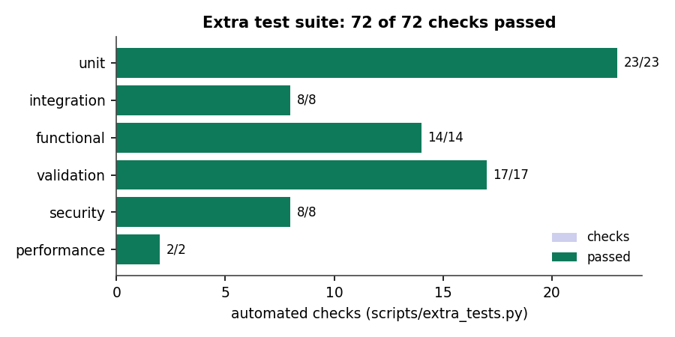
Fig. 7.1: Extended test suite: checks passed by category

7.2 Unit Testing
23 unit checks cover the feature extractor and the consensus rule.
Table 7.2: Unit tests
Area | Checks | Examples
Feature extraction | 18 | 47 features in a fixed order; suspicious TLD; brand outside the domain; IP host (dotted and hexadecimal); '@' symbol; URL shortener; executable extension; popular domain; two-level suffix split (co.uk); entropy of 'aaaa' is 0 and of 'ab' is 1 bit; normalisation; red flags for a bad URL and none for a plain reputable one
Consensus | 5 | First report stays pending; second confirms phishing; an opposing vote returns to pending; a trusted feed confirms at once; two safe votes confirm legitimate

7.3 Integration Testing
8 integration checks exercise the Detector together with the threat-intelligence store and the model.
Table 7.3: Integration checks
Check | Outcome
Obvious phishing URL decided by the model | phishing, p = 0.9989
Reputable URL | safe, p = 0.0207
Two community reports on a URL the model rates safe | verdict becomes phishing, decided by the community
Two safe reports on a URL the model flags | verdict becomes safe, decided by the community
A confirmed host covers its other pages | another page on the host is phishing, decided by the community
One pending phishing report | the score rises (0.9188 to 1.0 in the test)
training_examples after confirmations | contains the confirmed URLs with labels 0 or 1
mark_trained | clears the awaiting-training count

7.4 Functional Testing
14 functional checks run the HTTP API and the original pages through Flask's test client.
Table 7.4: Functional checks
Function | Check
GET /api/health | reports a ready model
GET /api/check | returns verdict, probability, decided_by, reason, red_flags, features (47 entries) and model
POST /api/report | returns the vote counts and status
GET /api/stats, /api/config, /api/checks | return the documented structures
GET /api/intel?status=, /api/intel/lookup | filter by status; return the report history of a URL (2 reports)
Pages /, /report, /community, /models | all render with HTTP 200
Form POST on / | shows a verdict

The interface was walked through by script: single check, batch check of 10 URLs, report form, threat-intelligence board and detail drawer, feed sync, retraining and the Models and Activity pages. Each flow worked and produced the screens shown in Chapter 8.

7.5 Security Testing
8 security checks passed.
Table 7.5: Security checks
Threat | Test | Result
SQL injection | URL http://x.com/'; DROP TABLE reports; -- and a reporter name containing a DROP statement | stored as data; tables intact
Cross-site scripting | A reported URL with a script tag; a reporter name with markup; a checked URL with a script tag | escaped on /community and /; no raw tag in the page
Cross-origin access | Access-Control-Allow-Origin on API responses | present as * (documented weakness)
Session state | Set-Cookie header | none set
Resource abuse | A 100,000-character note in a report | no crash

These are targeted checks, not a penetration test. Authentication, authorisation, rate limiting and abuse of the report channel were not tested because they do not exist in the application.

7.6 Validation and Edge Cases
17 validation checks passed. Invalid input is rejected with HTTP 400 and a JSON error; unusual but well-formed input is handled without error.
Table 7.6: Validation and edge cases
Input | Expected behaviour | Result
Empty, missing or whitespace-only URL | HTTP 400 | Pass
Unknown verdict in a report; empty URL in a report | HTTP 400 | Pass
Unknown status filter; lookup without a URL | HTTP 400 | Pass
Non-numeric limit | default limit used | Pass
Bare domain; no scheme with path and query | normalised and classified | Pass (HTTP 200)
Malformed port; unmatched bracket | no exception | Pass (HTTP 200)
5,000-character URL; unicode host; percent-encoded traversal | classified | Pass (HTTP 200)
javascript: and data: URLs | classified as text, never executed | Pass (HTTP 200)

7.7 Performance Testing
Timings were measured on the development machine (Intel Core i5-12500, 12 threads, 15.7 GB) with the Flask test client, so they exclude network latency and the browser.
Table 7.7: Measured response times
Measurement | Result
Feature extraction, one URL (2,000 URLs) | 0.077 ms
Feature extraction + model, one URL (500 URLs) | 0.407 ms
Model scoring of 8,000 feature rows | 0.0014 ms per URL
Featurising the 40,000-URL dataset | 4.0 s
GET /api/check (300 requests, includes a log write) | mean 8.04 ms, median 7.88 ms, p95 9.70 ms, max 16.16 ms
Training all three models (32,000 rows) | RF 12.2 s, XGBoost 2.7 s, LR 0.2 s

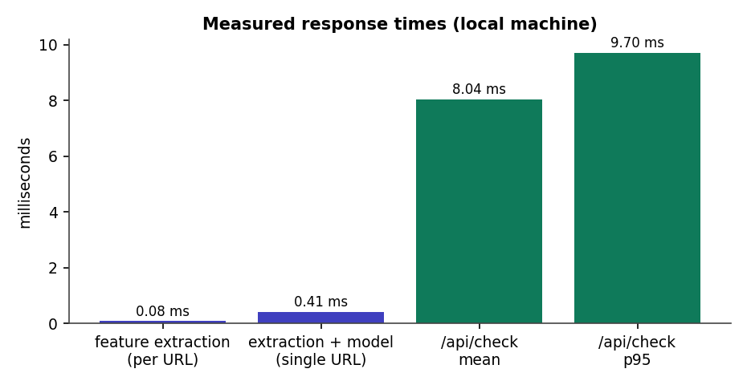
Fig. 7.2: Measured response times
The base paper reports about 0.20 ms per URL for its model; the single-URL figure here (0.41 ms) includes feature extraction and a Python call per URL, so the two numbers measure different things and are not compared as a result.

7.8 User Acceptance Testing
No user-acceptance test was carried out. The interface was exercised by the developers only, and no feedback from real analysts or reporters was collected. This is the most important missing piece of evidence for the claim that the system is easy to use, and it is listed as future work.

7.9 Limits of the Testing Done
- All tests run on one Windows machine with one browser (Chrome); other systems and browsers were not tested.
- There are no unit tests for the React frontend; it is checked by a production build and by scripted walkthroughs.
- There is no load or concurrency test; the behaviour under many simultaneous users, or during a retrain, is not measured.
- Model quality was measured on a held-out part of the same dataset and by cross-validation, not on live URLs collected after training.
- The security tests are targeted checks; there was no independent security review.
- The retraining experiment used random in-distribution URLs; it cannot show how well the loop adapts to a new campaign.

CHAPTER 8
RESULTS AND OUTPUT SCREENS

8.1 Output Screens
All screens are real captures of the running application at 1440 x 900 pixels, taken by script after loading real usage into it: a scenario of 42 checks, 19 community reports, a feed sync of 800 real URLs from OpenPhish and URLhaus, and a retrain from the interface. None is a mock-up.

Fig. 8.1: Landing page
The public front page: product name, the line "Machine learning + crowdsourced threat intelligence", a paste-a-link box, and a live badge showing the active model (XGBoost, F1 92.9 %, ROC-AUC 0.981) read from the API.
Fig. 8.2: Check URL: phishing verdict
A phishing URL (http://secure-paypal-login.account-verify.tk/signin?user=a) is checked. The verdict is Phishing, decided by the ML model, with a 99.9 % probability gauge, the risk scale marked at 35 % and 60 %, and buttons to report the URL.

Fig. 8.3: Check URL: safe verdict
A reputable page (wikipedia.org/wiki/Phishing) is scored 0.1 % and shown as Looks safe, with no red flags.

Fig. 8.4: Check URL: community overrides the model
A lookalike document-share URL that the model scores at 9.5 % (raw model score) is shown as Phishing at 97.0 %, decided by the community, after two reports. This is the zero-day behaviour of the system.

Fig. 8.5: Check URL: false positive corrected
docs.python.org was flagged by the model (raw score 60.1 %). After two safe reports the verdict is Looks safe, decided by the community, with the explanation "Confirmed legitimate by community consensus".

Fig. 8.6: Batch check of ten URLs
Ten pasted URLs are checked in one run (5 phishing, 5 safe). The table shows each verdict, probability and decided-by; the last row is decided by the community. A toast reports "Checked 10 URLs - 5 flagged as phishing".
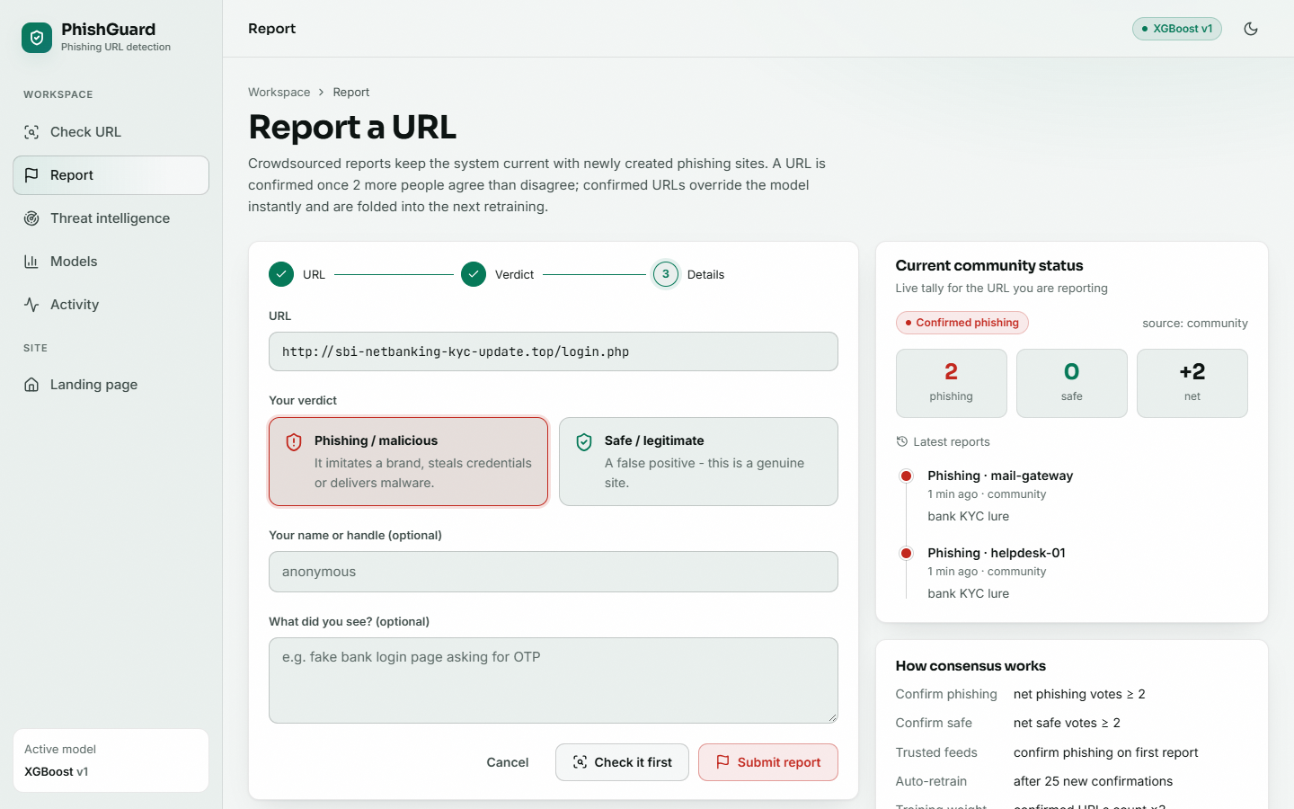
Fig. 8.7: Report a URL
The report form for http://sbi-netbanking-kyc-update.top/login.php: the three steps, the phishing or safe choice, reporter and note fields, the live community status (2 phishing, 0 safe, net +2, confirmed), the latest reports, and the consensus rules.
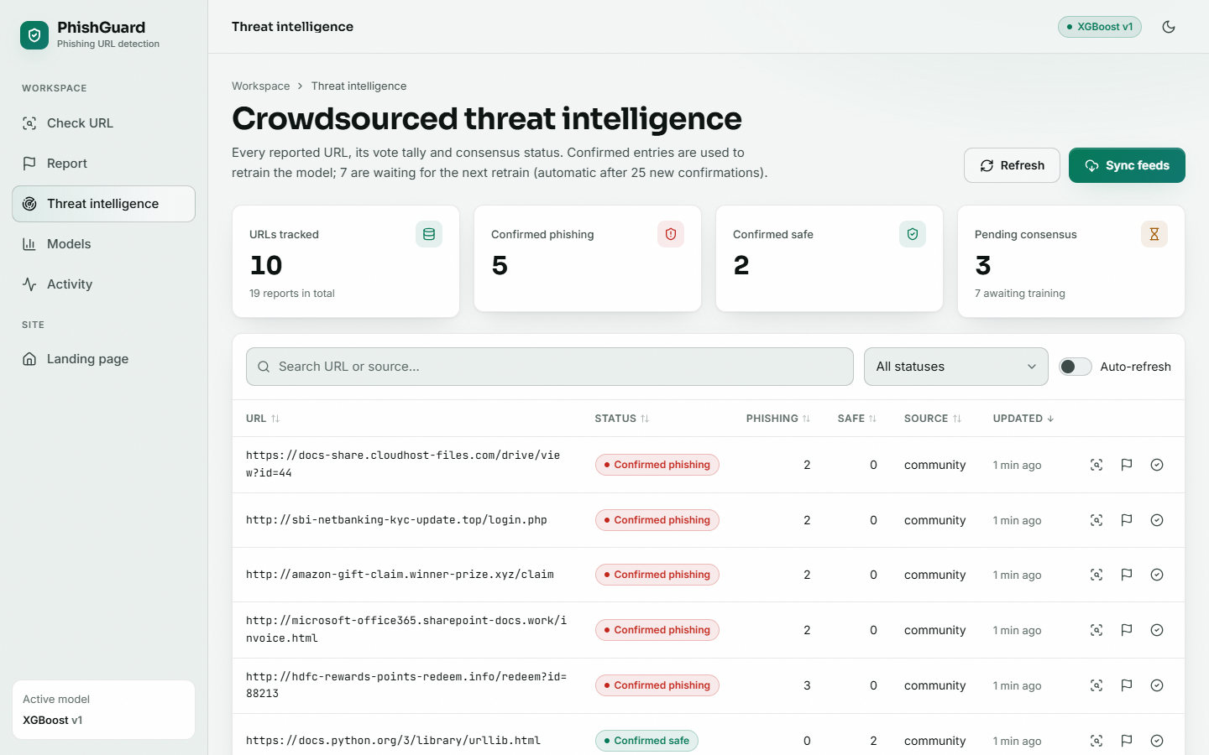
Fig. 8.8: Threat intelligence board
Counters (10 URLs tracked, 5 confirmed phishing, 2 confirmed safe, 3 pending; 7 awaiting training) and the table of entries with status, phishing and safe votes, source and age.
Fig. 8.9: Models: full page (version 1)
Held-out metrics as bars and radar, the comparison table (XGBoost 92.93 %, Random Forest 92.49 %, Logistic Regression 82.81 % accuracy), the XGBoost confusion matrix (3,745 / 255 / 311 / 3,689) and its top-10 feature importances, and the retrain control.

Fig. 8.10: Models: after retraining (version 2)
Version 2: trained on 33,953 rows including 807 community-confirmed URLs weighted x3, tested on 8,162; XGBoost F1 92.99 %. The topbar now reads XGBoost v2.

8.2 Model Performance
All figures in this section come from models/metrics.json (the shipped run), re-checked by scripts/measure_results.py, which re-scored the saved models on the same split and found exact agreement. The test set is 8,000 URLs (4,000 phishing, 4,000 legitimate) that no model saw in training.
Table 8.1: Held-out test results of the three classifiers
Model | Accuracy | Precision | Recall | F1 | ROC-AUC | FPR | Train (s)
XGBoost (selected) | 92.93 % | 93.53 % | 92.23 % | 92.88 % | 0.9809 | 6.38 % | 2.7
Random Forest | 92.49 % | 92.69 % | 92.25 % | 92.47 % | 0.9776 | 7.27 % | 12.2
Logistic Regression | 82.81 % | 86.94 % | 77.22 % | 81.80 % | 0.9218 | 11.60 % | 0.2

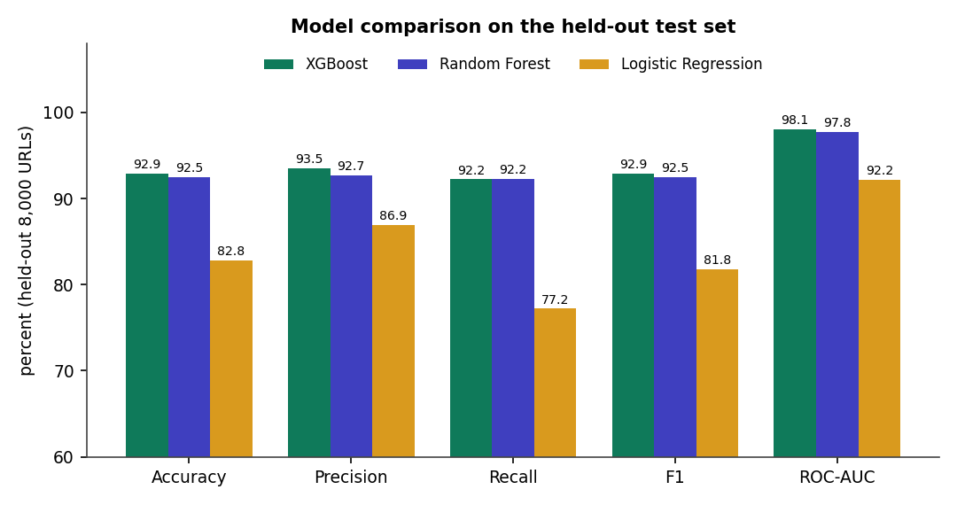
Fig. 8.11: Comparison of the three classifiers on five metrics
XGBoost is the best on every metric except recall, where Random Forest is higher by 0.02 points (92.25 % against 92.23 %). Logistic Regression misses about 23 % of phishing URLs (recall 77.2 %), so a linear boundary is not adequate. The top two models differ by 0.4 points of accuracy.

8.2.1 Confusion matrices
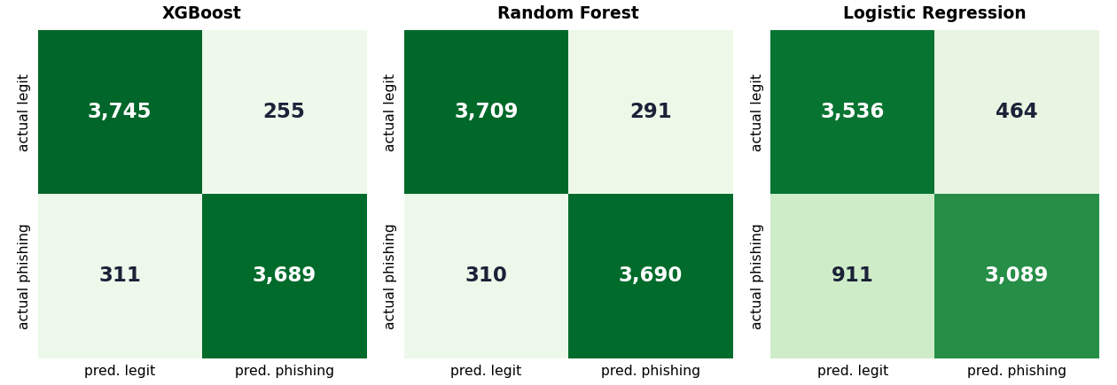
Fig. 8.12: Confusion matrices on the 8,000 test URLs
For XGBoost, 3,745 legitimate URLs were correctly passed and 255 wrongly flagged (a false-positive rate of 6.38 %); 3,689 phishing URLs were caught and 311 missed (a false-negative rate of 7.8 %). The error is balanced between the two kinds.

8.2.2 ROC curves
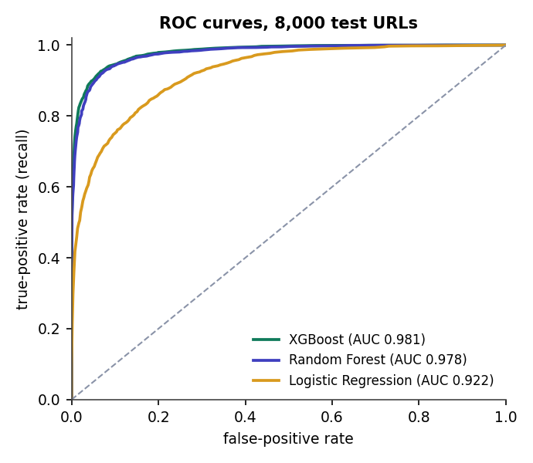
Fig. 8.13: ROC curves of the three models

8.2.3 Cross-validation
The same models were evaluated with 5-fold stratified cross-validation over all 40,000 URLs, the protocol used in the base paper [1].
Table 8.2: 5-fold cross-validation (mean +- standard deviation, %)
Model | Accuracy | Precision | Recall | F1 | ROC-AUC
XGBoost | 92.59 +- 0.19 | 92.91 +- 0.39 | 92.21 +- 0.28 | 92.56 +- 0.18 | 0.9792 +- 0.0010
Random Forest | 92.28 +- 0.28 | 92.28 +- 0.51 | 92.29 +- 0.26 | 92.28 +- 0.26 | 0.9764 +- 0.0008
Logistic Regression | 82.64 +- 0.35 | 86.37 +- 0.55 | 77.51 +- 0.46 | 81.70 +- 0.36 | 0.9190 +- 0.0031

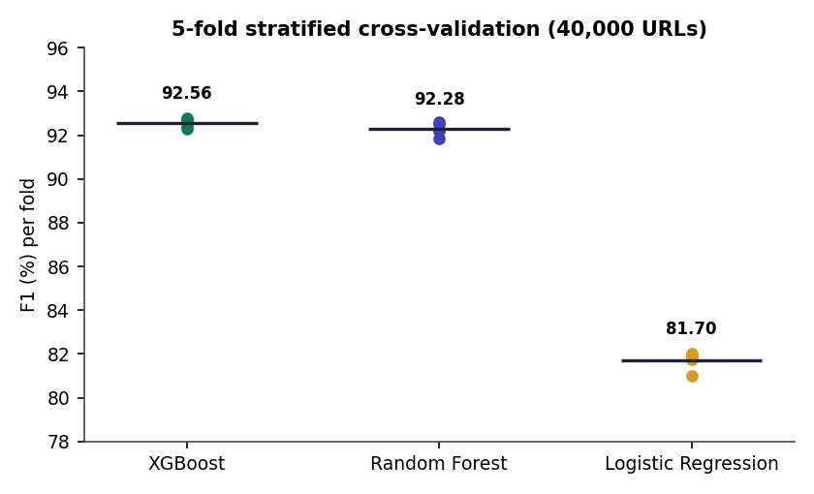
Fig. 8.14: F1 of each fold and the mean, per model
The standard deviation of XGBoost's F1 across folds is 0.18 points, so the held-out result is not a lucky split; the cross-validated F1 (92.56 %) is slightly lower than the held-out F1 (92.88 %).

8.3 Threshold, Feature and Data Analysis

8.3.1 Choice of threshold
The detector uses 0.60 for phishing and 0.35 for suspicious. The sweep below shows the trade-off for XGBoost: a lower threshold finds more phishing at the cost of more false alarms.
Table 8.3: XGBoost on the 8,000 test URLs at different probability thresholds
Threshold | Precision | Recall | F1 | FPR | False positives | False negatives
0.20 | 86.01 % | 96.98 % | 91.16 % | 15.78 % | 631 | 121
0.30 | 89.43 % | 95.23 % | 92.24 % | 11.25 % | 450 | 191
0.35 | 90.79 % | 94.43 % | 92.57 % | 9.58 % | 383 | 223
0.40 | 91.90 % | 93.85 % | 92.86 % | 8.28 % | 331 | 246
0.50 | 93.53 % | 92.23 % | 92.88 % | 6.38 % | 255 | 311
0.60 | 94.96 % | 90.00 % | 92.41 % | 4.78 % | 191 | 400
0.70 | 96.20 % | 87.38 % | 91.58 % | 3.45 % | 138 | 505
0.80 | 97.84 % | 82.83 % | 89.71 % | 1.82 % | 73 | 687
0.90 | 98.83 % | 75.75 % | 85.76 % | 0.90 % | 36 | 970

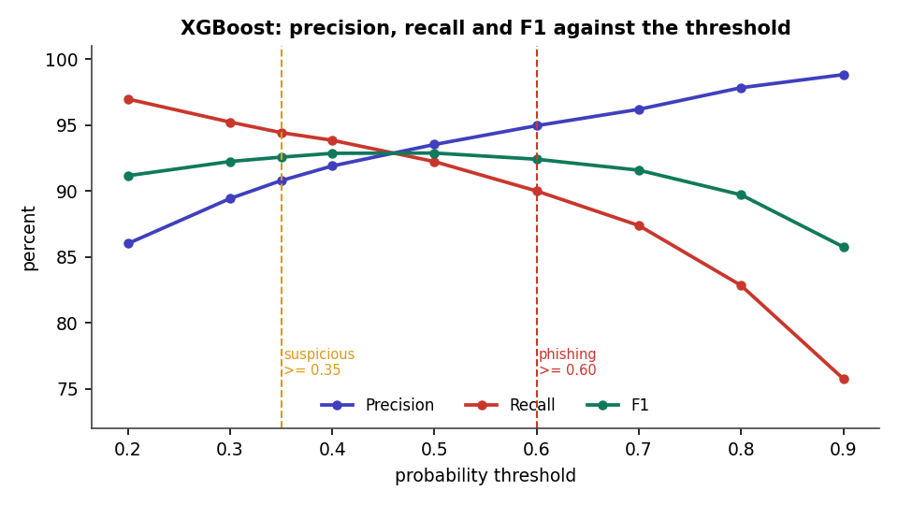
Fig. 8.15: Precision, recall and F1 against the threshold
F1 is highest between 0.40 and 0.50 (92.9 %). The deployed three-band scheme with the reputation discount gives: of 4,000 phishing URLs, 3,583 are called phishing, 187 suspicious and 230 safe; of 4,000 legitimate URLs, 3,621 are safe, 191 suspicious and 188 phishing. Counting only "phishing" as a positive gives precision 95.01 % and recall 89.58 %; counting suspicious as well gives precision 90.87 % and recall 94.25 %. The suspicious band therefore trades a few false alarms for 187 phishing URLs that would otherwise be reported safe.
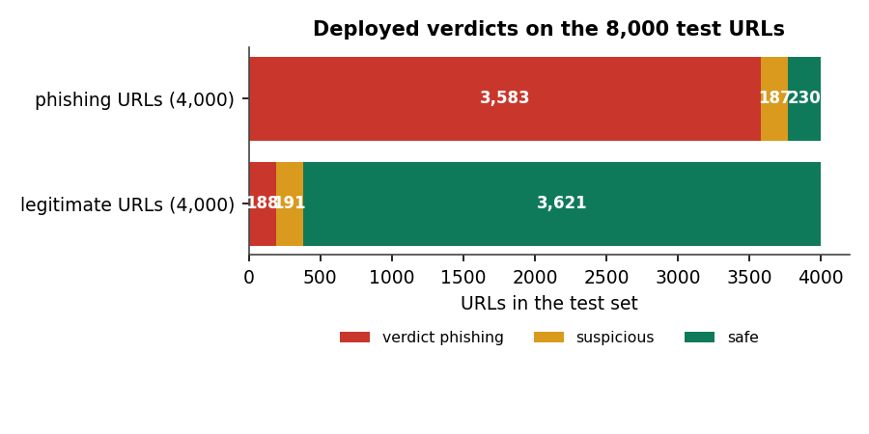
Fig. 8.16: Deployed verdicts on the test set

8.3.2 Which features matter
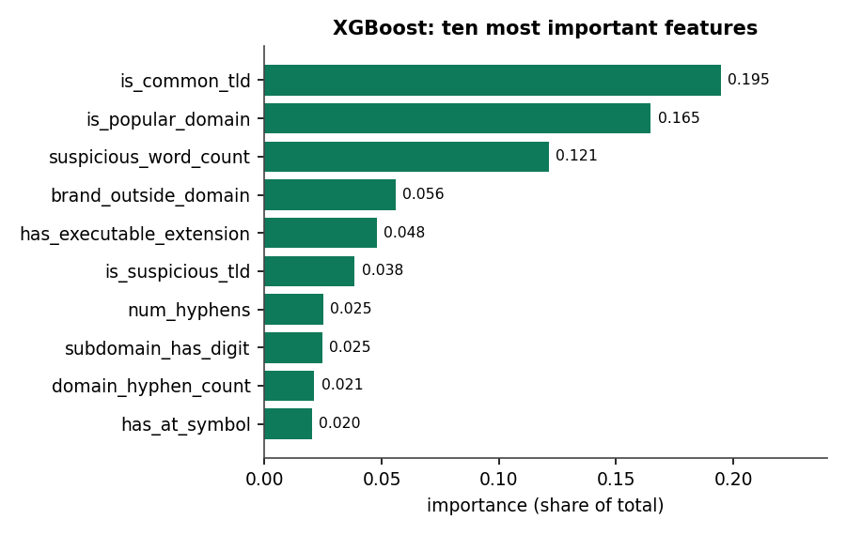
Fig. 8.17: Top-10 feature importances of the XGBoost model
The most important features are is_common_tld (0.195), is_popular_domain (0.165) and suspicious_word_count (0.121), followed by brand_outside_domain, has_executable_extension and is_suspicious_tld. Two of the top three are domain-reputation signals, so an ablation was run.
Table 8.4: Feature ablation (XGBoost refitted, threshold 0.5)
Features used | Count | Accuracy | F1 | ROC-AUC
lexical only | 23 | 89.28 % | 89.17 % | 0.9605
structural only | 9 | 64.91 % | 66.01 % | 0.7065
domain only | 15 | 78.71 % | 77.73 % | 0.8834
lexical + structural | 32 | 90.35 % | 90.20 % | 0.9672
lexical + domain | 38 | 92.46 % | 92.42 % | 0.9787
all 47 | 47 | 92.83 % | 92.76 % | 0.9811
without is_popular_domain | 46 | 92.70 % | 92.63 % | 0.9804
without is_common_tld | 46 | 92.89 % | 92.84 % | 0.9812
without both | 45 | 92.66 % | 92.59 % | 0.9806

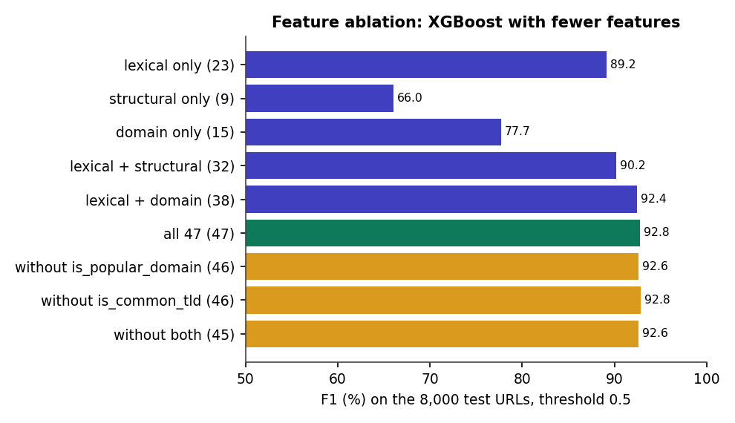
Fig. 8.18: F1 of XGBoost with different feature subsets
Lexical features alone reach F1 89.2 %; structural features alone are weak (66.0 %); domain features alone reach 77.7 %. Adding domain to lexical features gives 92.4 %, close to the full 92.8 %. Removing both of the two dominant features costs only 0.2 points, so the model is not relying on them alone. The refitted "all 47" model differs from the saved one by 0.1 point of accuracy because of run-to-run variation in XGBoost.

8.3.3 Learning curve
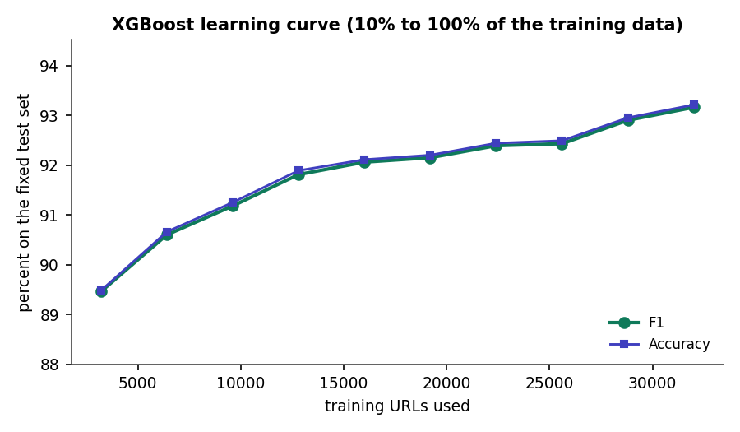
Fig. 8.19: XGBoost F1 and accuracy against the amount of training data
F1 rises from 89.5 % with 3,200 training URLs to 93.2 % with 32,000, and is still rising slowly at the end. More data would likely help; the 32,000-row point differs from the shipped model (92.88 %) by about 0.3 points because the rows were permuted for this experiment.

8.4 Crowdsourcing and Retraining Results

8.4.1 Zero-day override and false-positive correction
Table 8.5: Verdict before and after two community reports (demonstration run)
URL | Before reports | After reports
https://docs-share.cloudhost-files.com/drive/view?id=44 | safe (0.095, ml) | phishing (0.970, community)
http://sbi-netbanking-kyc-update.top/login.php | phishing (0.995, ml) | phishing (0.995, community)
https://docs.python.org/3/library/urllib.html | phishing (0.601, ml) | safe (0.030, community)
https://www.amazon.in/gp/cart/view.html | phishing (0.787, ml) | safe (0.030, community)

The lookalike document-share page is scored safe by the model (0.095) and becomes phishing at once after two reports; the two legitimate pages that the model flagged become safe after two safe reports each. In both directions the change takes effect on the next check, without retraining. The other four phishing lures in the run were already caught by the model, so the reports confirmed rather than changed them.

8.4.2 Feed synchronisation and retraining (version 1 to 2)
Synchronising the two public feeds added 800 URLs (OpenPhish 300, URLhaus 500) as trusted reports, giving 810 tracked URLs of which 805 were confirmed phishing. A retrain from the Models page then used the base 40,000 rows plus 807 confirmed URLs, repeated three times in the training portion, producing model version 2.
Table 8.6: Model metrics before and after the retraining demonstration
Model | v1 F1 (8,000 test) | v2 F1 (8,162 test) | v1 accuracy | v2 accuracy
XGBoost | 92.88 % | 92.99 % | 92.93 % | 92.91 %
Random Forest | 92.47 % | 92.86 % | 92.49 % | 92.72 %
Logistic Regression | 81.80 % | 81.98 % | 82.81 % | 82.87 %

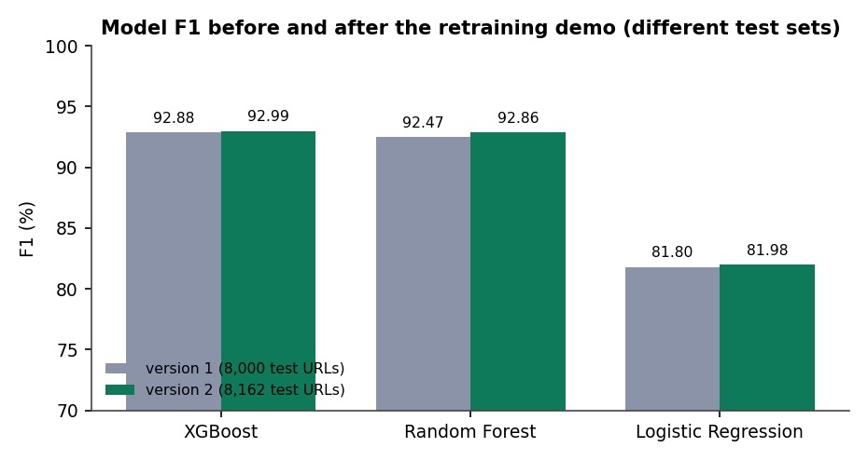
Fig. 8.20: F1 before and after retraining (note the different test sets)
The two versions were tested on different test sets (the split is recomputed on 40,807 rows, and the added URLs are mostly phishing), so the difference of about 0.1 points for XGBoost is not a measured improvement. What the run does show is that the loop works end to end: reports and feed URLs become training data, a new version is trained, the detector loads it, and the interface shows version 2 and zero entries awaiting training. XGBoost took 203.8 s in that run against 2.7 s in the original run; the run was concurrent with a browser polling the page and is not a clean timing.

8.4.3 Does retraining improve the model? A controlled experiment
To measure the effect of crowd data on unseen URLs, 250 to 2,000 correctly labelled test URLs were added to the training data (repeated three times) and the model was scored on the remaining test URLs, averaged over three random draws.
Table 8.7: Effect of adding confirmed URLs to training (mean of 3 draws)
Confirmed URLs added | Held-out URLs | F1 before | F1 after | Missed before | Missed after
250 | 7,750 | 92.82 % | 92.76 % | 305.0 | 305.3
500 | 7,500 | 92.85 % | 92.81 % | 295.0 | 297.0
1,000 | 7,000 | 92.79 % | 92.72 % | 277.3 | 277.7
2,000 | 6,000 | 92.83 % | 92.90 % | 238.0 | 235.3

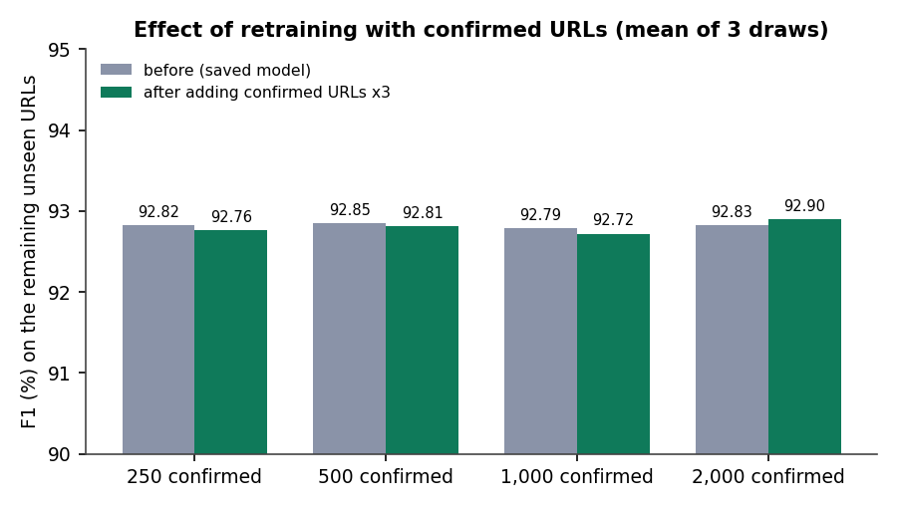
Fig. 8.21: F1 before and after adding confirmed URLs
The change is within +-0.1 point at every size (standard deviation of the paired difference 0.02 to 0.11 points). Adding random, correctly labelled URLs from the same distribution does not change the average score, which is what one would expect when the model has already seen 32,000 similar examples. The value of the loop here is the immediate override and the reversal of known mistakes. Whether retraining helps against a genuinely new campaign could not be tested with a static dataset, and is stated as an open question.

8.4.4 Response time
A check through the API takes 8.0 ms on average (p95 9.7 ms); extraction of the 47 features takes 0.077 ms per URL.

8.5 Comparison with the Base Paper
The comparison below must be read with care: the base paper and this project differ in data, features and model, so the numbers are not a head-to-head benchmark.
Table 8.8: PhishGuard against the base paper (different datasets and conditions)
Item | Base paper [1] | PhishGuard
Dataset | PhiUSIIL, 235,804 URLs (classes balanced by undersampling) | Sample of a public set, 40,000 URLs (balanced)
Features | 34 URL and page-content features after selection | 47 offline URL features
Model | LSTM + attention + dense hybrid network | XGBoost (best of three); RF and LR compared
Test accuracy | 99.80 % | 92.93 %
F1 | 0.9988 | 0.9288
Cross-validation | 5-fold (mean reported) | 5-fold: accuracy 92.59 %, F1 92.56 %
Time per URL | about 0.20 ms (model inference) | 0.41 ms (extraction + model, single URL); 8.0 ms through the API
Crowd loop | Designed; evaluated by a learning-curve simulation | Built and run end to end on real feed data; effect on average accuracy not measurable
Explainability | Not provided | Red flags and reason with each verdict

The base paper's accuracy is 6.9 points higher than this project's. Three differences probably explain much of the gap, but none was isolated experimentally: the base paper's dataset is about six times larger, its features include page content that this project deliberately does not compute, and its model is a deep network. This project does not claim to match or surpass the base paper's accuracy.

8.6 Sample Inputs and Outputs
Table 8.9: Verdicts of the live detector on a hand-written set of 14 URLs (empty community store)
URL | Verdict | Probability | Correct?
http://secure-paypal-login.account-verify.tk/signin?user=a | phishing | 0.9989 | Yes
http://192.168.1.5/wp-admin/bank/update.php | phishing | 0.9999 | Yes
http://paypal.com.verify-login.tk/signin?user=a&pwd=b | phishing | 0.9999 | Yes
http://bit.ly/3xYz9Ab | phishing | 0.9999 | Yes
http://apple-id-locked.support-center.xyz/unlock/account.html | phishing | 0.9998 | Yes
http://netflix-billing-update.com/payment/verify | phishing | 0.9939 | Yes
https://github.com/anthropics | safe | 0.0207 | Yes
https://www.wikipedia.org/wiki/Phishing | safe | 0.0008 | Yes
https://www.irctc.co.in/nget/train-search | safe | 0.0868 | Yes
https://docs.python.org/3/library/urllib.html | phishing | 0.6009 | No (false positive)
https://www.amazon.in/gp/cart/view.html | phishing | 0.7869 | No (false positive)
http://free-prize-winner-lucky.top/claim.exe | phishing | 0.9994 | Yes
https://stackoverflow.com/questions/11227809 | safe | 0.0020 | Yes
http://example-bank-secure.info/login.php?session=9f3a | phishing | 0.9083 | Yes

The eight phishing-style URLs are all caught, and four of the six legitimate URLs are passed. The two errors are discussed in the next section. The phishing-style URLs were written for this report, imitating common lure patterns; they are not live sites.

8.7 Success and Failure Analysis

8.7.1 Where the system succeeds
- URLs with an IP host, an '@' symbol, an abused TLD, brand names in sub-domains or several credential words are scored above 0.99.
- Well-known domains with common TLDs are scored near zero (wikipedia 0.001, stackoverflow 0.002, github 0.021).
- Known mistakes can be fixed in one step by two safe reports; new lures can be blocked by two phishing reports.
- The system degrades gracefully: malformed input never crashes it.

8.7.2 Where it fails
On the 8,000 test URLs XGBoost makes 255 false positives and 311 false negatives. Looking at the most confident errors shows what the features cannot see.
Table 8.10: The most confident errors of the XGBoost model on the test set
Kind | URL (truncated) | Model probability
False positive | namewiki.info/firstname/Dorion | 0.998
False positive | usaippon.us/racquetballfriendsplayerannc12006 | 0.994
False positive | twitter.com/mikeruiz1 | 0.990
False positive | abebooks.com/book-search/author/mavis-gallant/first-edition/pics/sortby/1/ | 0.990
False positive | bouchercon.info/nominees.html | 0.989
False negative | www.travelhoneymoon.wordpress.com/2016/03/30/tips-to-how-to-feel-happy | 0.002
False negative | formget.com/app/form/share/eP2Y-202367 | 0.002
False negative | cece.pixub.com/antispam-protector/antispam-protector/ | 0.006
False negative | veganvet.net/animal-issues-05-20-2014/ | 0.007
False negative | panopticlick.eff.org/browser-uniqueness.pdf | 0.011

- False negatives look like ordinary pages: a blog post on a blogging platform, a form-sharing page, a PDF on a research site. A phishing page hosted on a legitimate service has no suspicious URL features at all; only page content or reports can catch it.
- False positives look like unusual pages on small sites: personal profile pages, long identifiers and query strings, unfamiliar TLDs such as .info.
- Reputation list gaps: docs.python.org (0.601) and amazon.in (0.787) are flagged because the popular-domain list lacks python and applies no discount to the two-letter country TLD.
- Host-wide override: a confirmed phishing URL on a shared host marks every URL on that host as phishing, which would wrongly block a hosting service.

8.8 Limitations of the Results
- The dataset is a 40,000-URL sample from one source; results may not transfer to live traffic or to other datasets.
- The test set is part of the same dataset as the training set; no time-based split was possible because the data has no dates.
- No hyper-parameter tuning was done, so the model comparison reflects default-like settings.
- The retraining effect on new campaigns, and the behaviour with many dishonest reporters, were not measured.
- Latency was measured in process, without network or browser overhead; load tests were not run.
- The v1 and v2 metrics come from different test sets and cannot be compared directly.

8.9 Objectives against Outcomes
Table 8.11: Objectives measured against outcomes
No. | Objective | Outcome | Evidence | Status
1 | Collect and preprocess a URL dataset | 40,000 balanced URLs cleaned and split 80/20 | Chapter 6; data/urls_sample.csv | Achieved (sample size modest)
2 | Extract lexical, structural and domain features | 47 offline features in three groups with red flags | Chapter 6; 18 unit checks | Achieved
3 | Train and compare RF, XGBoost and LR | XGBoost best: F1 92.88 %, AUC 0.981; 5-fold CV F1 92.56 % | Tables in this chapter | Achieved
4 | Integrate crowdsourced threat intelligence | Vote consensus, trusted feeds, community-first decision; zero-day override shown | Section on crowdsourcing | Achieved (no administrator verification)
5 | Refine the model continuously | Retrain from the interface or after 25 confirmations; hot reload; v1 to v2 run | Section on retraining | Achieved as a mechanism; benefit on new campaigns not measured
6 | Real-time classification through a web interface | React UI and Flask API; mean check 8.0 ms | Output screens | Achieved (no sign-in)

CHAPTER 9
CONCLUSION

9.1 Summary of the Work
This project built PhishGuard, an adaptive phishing URL detection system that follows the three-stage design of the base paper: extract features from a URL, classify it with machine learning, and refine the system with crowdsourced threat intelligence. A balanced sample of 40,000 labelled URLs was cleaned and turned into 47 offline features; Random Forest, XGBoost and Logistic Regression were compared on the same split; and XGBoost was selected with accuracy 92.93 %, F1 92.88 % and ROC-AUC 0.981 on 8,000 held-out URLs, and F1 92.56 % in 5-fold cross-validation.
Around the classifier, the project built a community store in which two net votes, or one trusted feed report, confirm a URL; a confirmed verdict, phishing or safe, overrides the model at once; and confirmed URLs are folded into the training data by a retraining loop that reloads the new model without a restart. A Flask API, a command-line interface and a seven-page React interface make the whole pipeline usable.

9.2 Objectives Achieved
Table 9.1: Objectives and their status
Objective | Achieved? | Note
1. Collect and preprocess a dataset | Yes | 40,000 URLs from a public set; one source
2. Extract lexical, structural and domain features | Yes | 47 features, 3 groups, red flags
3. Train and compare RF, XGBoost, LR | Yes | XGBoost F1 92.88 %; LR is clearly weaker
4. Integrate crowdsourced threat intelligence | Yes | Consensus, trusted feeds, community-first decisions; no administrator review
5. Refine the model continuously | Mechanism: yes; effect: not measurable here | Retrain and hot reload run end to end; no gain on in-distribution data
6. Real-time classification with a web interface | Yes | Mean API check 8.0 ms; no sign-in

9.3 Key Findings
1. Tree ensembles on 47 engineered URL features reach 92.9 % accuracy; logistic regression reaches only 82.8 %, so the problem is not linearly separable in these features.
2. Lexical features carry most of the signal (F1 89.2 % alone); structural features alone are weak; adding domain features gives the final 3 to 4 points.
3. The model does not depend on its two strongest features: removing both costs only 0.2 points of F1.
4. A well-chosen threshold matters: F1 is flat between 0.40 and 0.60, but the 0.35 suspicious band recovers 187 phishing URLs that would otherwise read as safe.
5. The community override works in both directions and takes effect immediately: a lookalike page scored 9.5 % became phishing at 97 % after two reports, and two flagged legitimate pages were cleared.
6. Retraining on random correctly labelled URLs from the same distribution does not change the average F1 (within 0.1 point); the loop's value is the override, not the average.
7. URL-only features cannot catch phishing pages on clean-looking domains, and a hand-written reputation list causes false positives on legitimate sites such as docs.python.org.
Fig. 9.1: Summary: the three classifiers on the held-out test set

9.4 Practical Applications
- A first-line link checker for a team or a small organisation, with a shared community list of confirmed phishing and safe URLs.
- A teaching tool for URL-based phishing detection: its features, red flags, thresholds and retraining are visible in the interface.
- A back end for a browser extension, a mail-gateway plug-in or a chat bot through the JSON API.
- A test bed for studying crowd-fed learning, since the consensus rule, the weight and the thresholds are single constants in config.py.

9.5 Known Limitations
- Small, single-source dataset; the 92.9 % accuracy is not comparable with the base paper's 99.8 %.
- URL-only features; clean-looking hosts and ordinary-looking pages are missed (311 false negatives of 4,000 phishing URLs).
- Hand-written reputation list (145 domains).
- Anonymous vote-based confirmation without sign-in, moderation, rate limiting or reporter reputation; host-wide override.
- Benefit of retraining on new campaigns not measured; v1 and v2 metrics not comparable.
- No load, concurrency or user-acceptance testing.

CHAPTER 10
FUTURE SCOPE

10.1 Improvements
- Evaluate on a larger and more recent dataset such as PhiUSIIL [17], and on URLs collected after the training date, to measure generalisation honestly.
- Tune the hyper-parameters and add calibration, so that the probability is a true probability and the thresholds have a principled basis.
- Replace the hand-written popular-domain list with a ranked list such as a top-sites list, and handle country-code domains.
- Make host-level override smarter: apply it to a host only after several distinct URLs are confirmed, and never to shared-hosting providers.
- Add an administrator verification queue before reports reach the training set, as the base paper does [1].

10.2 Additional Features
- Sign-in, roles, reporter reputation and rate limiting, so that votes can be weighted and abuse limited.
- Optional page-level features (title, form fields, redirects) fetched in a sandbox for URLs the model is unsure about.
- A browser extension and an e-mail plug-in using the existing API.
- Export of confirmed URLs as a feed, and import of further public feeds.
- A drift monitor that tracks the score distribution and recent false-positive reports.

10.3 Scalability and Deployment
- Move the community store from SQLite to a server database when many reporters write at once.
- Run the API behind a production WSGI server, with the model loaded once per worker and a shared reload signal.
- Cache verdicts for popular URLs and batch scoring, since the model scores 8,000 rows in about 11 ms.
- Containerise the API and the frontend for a repeatable deployment; add authentication and TLS in front.

10.4 Further Research
- Reproduce the base paper's LSTM-attention model on the same data and compare it with the tree ensembles under identical conditions.
- Study the crowd loop under realistic noise: simulate dishonest and careless reporters and measure how many votes the consensus needs.
- Evaluate adaptation to new campaigns with a time-split dataset or a live feed, which this static sample could not do.
- Add explanation methods such as SHAP values to the red flags, and study their effect on user trust.
- Investigate adversarial URLs crafted to defeat the features, and countermeasures [1].

REFERENCES
References 2 to 5 are the works listed in the batch literature survey; they were recorded by title, venue and year only and were not independently retrieved, so this report does not describe their methods or results.
[1] L. Aldhuwayhi and A. Alromih, "A dynamic phishing URL detection system integrating advanced machine learning and crowdsourced threat intelligence," IEEE Access, vol. 14, pp. 88393-88404, 2026, doi: 10.1109/ACCESS.2026.3700833.
[2] "Phishing URL detection using machine learning," Journal of Advanced Research in Production and Industrial Engineering, 2023.
[3] "Real-time phishing URL detection using reinforcement learning," International Journal of Science and Research (IJSR), 2025.
[4] "Phishing URL detection using machine learning and deep learning," in Proc. 2024 IEEE World AI IoT Congress (AIIoT), 2024.
[5] "Automated phishing detection through URL analysis and machine learning," Communications on Applied Nonlinear Analysis, 2025.
[6] V. Vajrobol, B. B. Gupta and A. Gaurav, "Mutual information based logistic regression for phishing URL detection," Cyber Security and Applications, vol. 2, p. 100044, Jan. 2024, doi: 10.1016/j.csa.2024.100044.
[7] T. Etem and M. Teke, "Advanced phishing detection: Leveraging t-SNE feature extraction and machine learning on a comprehensive URL dataset," Acta Infologica, vol. 231, no. 221, pp. 213-221, 2024, doi: 10.26650/acin.1521835.
[8] S. Alnemari and M. Alshammari, "Detecting phishing domains using machine learning," Applied Sciences, vol. 13, no. 8, p. 4649, Apr. 2023, doi: 10.3390/app13084649.
[9] U. A. Butt, R. Amin, H. Aldabbas, S. Mohan, B. Alouffi and A. Ahmadian, "Cloud-based email phishing attack using machine and deep learning algorithm," Complex & Intelligent Systems, vol. 9, no. 3, pp. 3043-3070, Jun. 2023, doi: 10.1007/s40747-022-00760-3.
[10] D. Rathee and S. Mann, "Detection of e-mail phishing attacks - using machine learning and deep learning," International Journal of Computer Applications, vol. 183, no. 47, pp. 1-7, Jan. 2022, doi: 10.5120/ijca2022921868.
[11] K. S. Priya, J. Chandrika and M. P. Lakshmi, "Machine learning-based phishing website detection: a comprehensive approach for cyber security," in Proc. 5th Int. Conf. Recent Trends in Computer Science and Technology (ICRTCST), Apr. 2024, pp. 344-349, doi: 10.1109/ICRTCST61793.2024.10578472.
[12] S. Sawant, R. Savakhande, O. Sankhe and S. Tamboli, "Phishing detection by integrating machine learning and deep learning," in Proc. 11th Int. Conf. Computing for Sustainable Global Development (INDIACom), Feb. 2024, pp. 1078-1083, doi: 10.23919/INDIACom61295.2024.10499100.
[13] Z. Fan, "Detecting and classifying phishing websites by machine learning," in Proc. 3rd Int. Conf. Applied Machine Learning (ICAML), Jul. 2021, pp. 48-51, doi: 10.1109/ICAML54311.2021.00018.
[14] A. Assefa and R. Katarya, "Intelligent phishing website detection using deep learning," in Proc. 8th Int. Conf. Advanced Computing and Communication Systems (ICACCS), vol. 1, Mar. 2022, pp. 1741-1745, doi: 10.1109/ICACCS54159.2022.9785003.
[15] H. Huang, N. Sun, M. Tani, Y. Zhang, J. Jiang and S. Jha, "Unmasking disinformation: Enhancing cyber threat intelligence through crowdsourced analysis and AI-driven training," in Proc. 59th Hawaii Int. Conf. System Sciences (HICSS), 2026, pp. 6049-6058, doi: 10.24251/HICSS.2026.743.
[16] K. Lazaros, A. G. Vrahatis and S. Kotsiantis, "Human-in-the-loop artificial intelligence: A systematic review of concepts, methods, and applications," Entropy, vol. 28, no. 4, p. 377, Mar. 2026, doi: 10.3390/e28040377.
[17] A. Prasad and S. Chandra, "PhiUSIIL phishing URL (website)," UCI Machine Learning Repository, 2024, doi: 10.1016/j.cose.2023.103545.
[18] J. Ma, L. K. Saul, S. Savage and G. M. Voelker, "Beyond blacklists: Learning to detect malicious web sites from suspicious URLs," in Proc. 15th ACM SIGKDD Int. Conf. Knowledge Discovery and Data Mining, 2009, pp. 1245-1254.
[19] O. K. Sahingoz, E. Buber, O. Demir and B. Diri, "Machine learning based phishing detection from URLs," Expert Systems with Applications, vol. 117, pp. 345-357, 2019.
[20] K. Krombholz, H. Hobel, M. Huber and E. Weippl, "Advanced social engineering attacks," Journal of Information Security and Applications, vol. 22, pp. 113-122, Jun. 2015, doi: 10.1016/j.jisa.2014.09.005.
[21] L. Breiman, "Random forests," Machine Learning, vol. 45, no. 1, pp. 5-32, 2001.
[22] T. Chen and C. Guestrin, "XGBoost: A scalable tree boosting system," in Proc. 22nd ACM SIGKDD Int. Conf. Knowledge Discovery and Data Mining, 2016, pp. 785-794.
[23] F. Pedregosa et al., "Scikit-learn: Machine learning in Python," Journal of Machine Learning Research, vol. 12, pp. 2825-2830, 2011.
[24] C. E. Shannon, "A mathematical theory of communication," Bell System Technical Journal, vol. 27, no. 3, pp. 379-423, Jul. 1948.
[25] "Using machine learning to detect malicious URLs," public dataset repository (data/data.csv). [Online]. Available: https://github.com/faizann24/Using-machine-learning-to-detect-malicious-URLs
[26] OpenPhish, "Phishing feed," and abuse.ch, "URLhaus: online malware URL feed." [Online]. Available: https://openphish.com and https://urlhaus.abuse.ch
[27] Pallets Projects, "Flask documentation." [Online]. Available: https://flask.palletsprojects.com
[28] Meta Platforms, "React documentation." [Online]. Available: https://react.dev

APPENDIX A
IMPORTANT CODE
The listings below are the real source code, extracted by script from the files named in each caption.

A.1 Feature extraction (phishguard/features.py)
Listing: extract_features
def extract_features(url: str) -> dict[str, float]:
"""Compute the full feature dictionary for one URL."""
norm = normalize_url(url)
decoded = unquote(norm)
parts = _safe_split(norm)
host = (parts.hostname or "").lower()
path = parts.path or ""
query = parts.query or ""
fragment = parts.fragment or ""
lower = norm.lower()
sub, domain, tld = split_host(host)
ip_host = is_ip(host)

tokens = [t for t in _TOKEN_SPLIT.split(lower) if t]
digits = sum(c.isdigit() for c in norm)
letters = sum(c.isalpha() for c in norm)
length = max(len(norm), 1)

brand_in_domain = int(bool(_BRAND_RE.search(domain))) if domain else 0
brand_elsewhere = int(bool(_BRAND_RE.search(sub + path + query))) and not brand_in_domain

f: dict[str, float] = {
# ---- lexical -------------------------------------------------------
"url_length": len(norm),
"host_length": len(host),
"path_length": len(path),
"query_length": len(query),
"fragment_length": len(fragment),
"num_dots": norm.count("."),
"num_hyphens": norm.count("-"),
"num_underscores": norm.count("_"),
"num_slashes": norm.count("/") - 2, # ignore the scheme's //
"num_digits": digits,
"digit_ratio": digits / length,
"num_special_chars": sum(c in _SPECIAL_CHARS for c in norm),
"has_at_symbol": int("@" in norm),
"num_query_params": len([p for p in query.split("&") if p]) if query else 0,
"num_equals": norm.count("="),
"num_ampersands": norm.count("&"),
"num_percent": norm.count("%"),
"url_entropy": shannon_entropy(lower),
"suspicious_word_count": len(_SUSP_RE.findall(lower)),
"longest_token_length": max((len(t) for t in tokens), default=0),
"has_https_in_path_or_host": int("https" in host or "https" in path.lower()),
"has_encoded_chars": int(decoded != norm),
"letter_ratio": letters / length,
# ---- structural ----------------------------------------------------
"is_ip_host": int(ip_host),
"has_port": int(parts.port is not None),
"nonstandard_port": int(parts.port not in (None, 80, 443)),
"num_subdomains": 0 if ip_host or not sub else sub.count(".") + 1,
"path_depth": len([p for p in path.split("/") if p]),
"has_double_slash_in_path": int("//" in path),
"is_url_shortener": int(host in URL_SHORTENERS or f"{domain}.{tld}" in URL_SHORTENERS),
"has_file_extension": int(bool(_FILE_EXT.search(path.split("/")[-1]))) if path else 0,
"has_executable_extension": int(bool(_EXEC_EXT.search(path))),
# ---- domain --------------------------------------------------------
"domain_length": len(domain),
"domain_entropy": shannon_entropy(domain),
"domain_digit_count": sum(c.isdigit() for c in domain),
"domain_hyphen_count": domain.count("-"),
"domain_vowel_ratio": (sum(c in "aeiou" for c in domain) / len(domain)) if domain else 0.0,
"domain_max_consonant_run": _max_consonant_run(domain),
"tld_length": len(tld),
"is_suspicious_tld": int(tld.split(".")[-1] in SUSPICIOUS_TLDS),
"is_common_tld": int(tld.split(".")[-1] in COMMON_TLDS),
"brand_in_domain": brand_in_domain,
"brand_outside_domain": int(brand_elsewhere),
"subdomain_length": len(sub),
"subdomain_has_digit": int(any(c.isdigit() for c in sub)),
"tld_in_subdomain": int(any(t in _TLD_TOKENS for t in sub.split(".") if t)),
"is_popular_domain": int(domain in POPULAR_DOMAINS and not ip_host),
}
return f

A.2 Training and evaluation (phishguard/train.py)
Listing: build_models
def build_models() -> dict:
models = {
"random_forest": RandomForestClassifier(
n_estimators=300, max_depth=None, min_samples_leaf=1, n_jobs=-1,
class_weight="balanced", random_state=config.RANDOM_STATE,
),
"logistic_regression": make_pipeline(
StandardScaler(),
LogisticRegression(max_iter=2000, C=1.0, class_weight="balanced",
random_state=config.RANDOM_STATE),
),
}
if HAS_XGB:
models["xgboost"] = XGBClassifier(
n_estimators=400, max_depth=8, learning_rate=0.08, subsample=0.9,
colsample_bytree=0.9, eval_metric="logloss", n_jobs=-1,
random_state=config.RANDOM_STATE,
)
else: # fallback if xgboost isn't installed
models["xgboost"] = GradientBoostingClassifier(
n_estimators=300, max_depth=5, random_state=config.RANDOM_STATE)
return models

A.3 Threat intelligence (phishguard/threat_intel.py)
Listing: ThreatIntel.report
def report(self, url: str, verdict: str, reporter: str = "anonymous",
note: str = "", source: str = "community", trusted: bool = False) -> dict:
"""Record a report and recompute consensus for the URL."""
verdict = verdict.lower().strip()
if verdict not in ("phishing", "safe"):
raise ValueError("verdict must be 'phishing' or 'safe'")
url_norm = normalize_url(url)
if not url_norm:
raise ValueError("empty URL")
now = _now()
with self._conn() as c:
c.execute(
"INSERT INTO reports(url_norm,url,verdict,reporter,source,note,created_at)"
" VALUES (?,?,?,?,?,?,?)",
(url_norm, url.strip(), verdict, reporter or "anonymous", source, note, now),
)
row = c.execute("SELECT * FROM intel WHERE url_norm=?", (url_norm,)).fetchone()
if row is None:
p, s = (1, 0) if verdict == "phishing" else (0, 1)
c.execute(
"INSERT INTO intel(url_norm,url,phishing_votes,safe_votes,status,source,"
"first_seen,last_updated) VALUES (?,?,?,?,?,?,?,?)",
(url_norm, url.strip(), p, s, "pending", source, now, now),
)
p_votes, s_votes = p, s
else:
p_votes = row["phishing_votes"] + (verdict == "phishing")
s_votes = row["safe_votes"] + (verdict == "safe")
status = self._consensus(p_votes, s_votes, trusted and verdict == "phishing")
c.execute(
"UPDATE intel SET phishing_votes=?, safe_votes=?, status=?, last_updated=?,"
" used_in_training = CASE WHEN status=? THEN used_in_training ELSE 0 END"
" WHERE url_norm=?",
(p_votes, s_votes, status, now, status, url_norm),
)
return self.lookup(url)

Listing: ThreatIntel._consensus
def _consensus(p_votes: int, s_votes: int, trusted: bool = False) -> str:
net = p_votes - s_votes
if trusted or net >= config.CONSENSUS_THRESHOLD:
return "confirmed_phishing"
if -net >= config.CONSENSUS_THRESHOLD:
return "confirmed_safe"
return "pending"

A.4 Real-time decision (phishguard/detector.py)
Listing: Detector.check
def check(self, url: str, log: bool = True) -> dict:
url_norm = normalize_url(url)
if not url_norm:
raise ValueError("Please enter a URL.")
feats = extract_features(url_norm)
flags = explain_features(feats)
result = {
"url": url.strip(),
"normalized_url": url_norm,
"red_flags": flags,
"features": {k: (round(v, 4) if isinstance(v, float) else v) for k, v in feats.items()},
"model": self.model_name,
"model_version": self.model_version,
}

# 1. crowdsourced intelligence
intel = self.ti.lookup(url_norm) or self.ti.lookup_host(url_norm)
ml_prob = self.ml_probability(url_norm) if self.ready else None
result["ml_probability"] = None if ml_prob is None else round(ml_prob, 4)
result["community"] = None
if intel:
result["community"] = {
"status": intel["status"],
"phishing_votes": intel["phishing_votes"],
"safe_votes": intel["safe_votes"],
"source": intel["source"],
"last_updated": intel["last_updated"],
}
if intel and intel["status"] == "confirmed_phishing":
result.update(verdict="phishing", probability=max(0.97, ml_prob or 0),
decided_by="community", reason=(
f"Confirmed phishing by crowdsourced threat intelligence "
f"({intel['phishing_votes']} phishing vs {intel['safe_votes']} safe "
f"reports, source: {intel['source']})."))
elif intel and intel["status"] == "confirmed_safe":
result.update(verdict="safe", probability=min(0.03, ml_prob or 0),
decided_by="community",
reason="Confirmed legitimate by community consensus.")
elif ml_prob is None:
result.update(verdict="unknown", probability=None, decided_by="none",
reason="No trained model found - run `python run.py train` first.")
else:
# 2./3. ML with soft community evidence
prob = ml_prob
reputable = feats["is_popular_domain"] and (feats["is_common_tld"] or feats["tld_length"] > 2)
if reputable: # domain-reputation adjustment for well-known registered domains
prob *= 0.4
if intel:
net = intel["phishing_votes"] - intel["safe_votes"]
prob = float(np.clip(prob + 0.15 * net, 0.0, 1.0))
if prob >= config.PHISHING_THRESHOLD:
verdict = "phishing"
elif prob >= config.SUSPICIOUS_THRESHOLD:
verdict = "suspicious"
else:
verdict = "safe"
reason = (f"{self.model_name.replace('_', ' ').title()} estimates a "
f"{prob*100:.1f}% phishing probability from {len(FEATURE_NAMES)} "
f"lexical, structural and domain features.")
if reputable:
reason += " Reduced because the registered domain is a well-known legitimate site."
if intel:
reason += (f" Adjusted by {intel['phishing_votes']} phishing / "
f"{intel['safe_votes']} safe pending community reports.")
result.update(verdict=verdict, probability=round(prob, 4), decided_by="ml",
reason=reason)

if log:
self.ti.log_check(url_norm, result["verdict"], result["probability"],
result["decided_by"])
return result

A.5 Retraining (phishguard/retrain.py)
Listing: retrain
def retrain(ti: ThreatIntel | None = None, max_rows: int | None = None,
verbose: bool = True) -> dict:
ti = ti or ThreatIntel()
if not _retrain_lock.acquire(blocking=False):
return {"skipped": True, "reason": "a retrain is already running"}
try:
base = load_dataset(max_rows=max_rows)
crowd = ti.training_examples()
crowd_df = pd.DataFrame(crowd, columns=["url", "label"]).astype({"url": str, "label": int})
if verbose:
print(f"Base dataset: {len(base)} rows | crowdsourced confirmed: {len(crowd_df)} rows")

# remove base rows that the crowd has since re-labelled
if len(crowd_df):
base = base[~base["url"].isin(crowd_df["url"])]
full = pd.concat([base, crowd_df], ignore_index=True)
weights = np.concatenate([
np.ones(len(base)), np.full(len(crowd_df), config.CROWD_SAMPLE_WEIGHT)])

X = featurize_urls(full["url"].tolist())
y = full["label"].astype(int).to_numpy()
X_tr, X_te, y_tr, y_te, w_tr, _ = train_test_split(
X, y, weights, test_size=config.TEST_SIZE,
random_state=config.RANDOM_STATE, stratify=y)

# sample weights are passed by duplicating weighted rows (works for every model)
reps = np.round(w_tr).astype(int)
X_tr = np.repeat(X_tr, reps, axis=0)
y_tr = np.repeat(y_tr, reps, axis=0)

summary = train_all(X_tr, y_tr, X_te, y_te, verbose=verbose, meta={
"base_rows": int(len(base)),
"crowd_rows": int(len(crowd_df)),
"crowd_weight": config.CROWD_SAMPLE_WEIGHT,
})
summary["crowd_marked_trained"] = ti.mark_trained()
return summary
finally:
_retrain_lock.release()

A.6 API layer (backend/server.py)
Listing: build_app
def build_app(ti: ThreatIntel | None = None, detector: Detector | None = None):
ti = ti or ThreatIntel()
det = detector or Detector(ti)
app = create_app(ti, det)

@app.after_request
def cors(resp):
resp.headers["Access-Control-Allow-Origin"] = "*"
resp.headers["Access-Control-Allow-Headers"] = "Content-Type"
resp.headers["Access-Control-Allow-Methods"] = "GET, POST, OPTIONS"
return resp

@app.get("/api/health")
def api_health():
return jsonify({"ok": True, "model_ready": det.ready, "model": det.model_name,
"model_version": det.model_version})

@app.get("/api/config")
def api_config():
return jsonify({
"consensus_threshold": config.CONSENSUS_THRESHOLD,
"auto_retrain_every": config.AUTO_RETRAIN_EVERY,
"crowd_sample_weight": config.CROWD_SAMPLE_WEIGHT,
"phishing_threshold": config.PHISHING_THRESHOLD,
"suspicious_threshold": config.SUSPICIOUS_THRESHOLD,
"threat_feeds": list(config.THREAT_FEEDS),
"feature_count": len(FEATURE_NAMES),
"feature_groups": FEATURE_GROUPS,
})

@app.get("/api/checks")
def api_checks():
return jsonify(ti.recent_checks(_limit(20)))

@app.get("/api/intel")
def api_intel():
status = request.args.get("status") or None
if status and status not in STATUSES:
return jsonify({"error": f"unknown status '{status}'"}), 400
return jsonify(ti.recent(_limit(200), status))

@app.get("/api/intel/lookup")
def api_intel_lookup():
url = request.args.get("url", "").strip()
if not url:
return jsonify({"error": "Please enter a URL."}), 400
return jsonify({"entry": ti.lookup(url)})

return app

APPENDIX B
INSTALLATION AND USER GUIDE

B.1 Installation
1. Install Python 3.10 or later and Node.js 18 or later.
2. Open a terminal in the 8.ProjectCode folder and run pip install -r requirements.txt.
3. Run run.bat. It trains the models if they are missing (under a minute), installs the frontend packages on first use, starts the API on port 8103 and the interface on port 5103, and opens http://127.0.0.1:5103.
4. To run the checks, use python tests.py, python scripts/smoke_test.py and python scripts/extra_tests.py.

B.2 User guide
Table B.1: How to use the main screens
To do this | Open | Steps
Check one URL | Check URL | Paste or type the URL (the scheme is optional), press Check. Read the verdict, the probability gauge, the red flags and the reason.
Check many URLs | Check URL, Batch tab | Drop a .txt or .csv file or paste one URL per line (up to 100), press Check.
Report a URL | Report | Enter the URL, choose phishing or safe, optionally add your name and a note, press Submit. Two net votes confirm it.
See what the community reported | Threat intelligence | Search or filter the table; click a row for the report history.
Import public feeds | Threat intelligence | Press Sync feeds, then Start sync (internet needed).
Compare models and retrain | Models | Read the table, the confusion matrix and the importances; press Retrain now and confirm.
Review activity | Activity | See every check, the probability trend and the verdict mix.

B.3 Troubleshooting
- "Cannot reach the PhishGuard backend" - start the API (python backend/server.py) and check port 8103.
- No verdicts, "unknown" - no model found; run python run.py train.
- Feed sync fails - the feeds need an internet connection; the application keeps working offline.
- A warning about XGBoost model versions - the saved model was written by a different XGBoost version; it still loads and works, and retraining rewrites it.

APPENDIX C
ADDITIONAL SCREENS
These are the remaining output screens that are not shown in Chapter 8, two to a row. Each caption is followed by a short description.
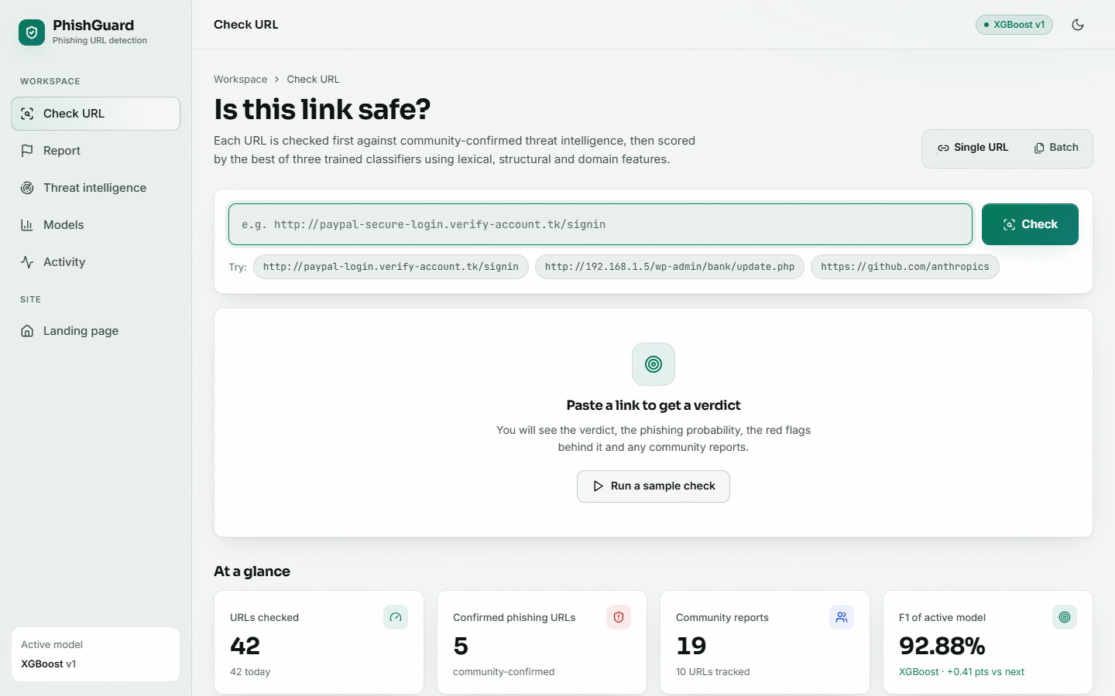  Fig. C.1: Check URL: home |   Fig. C.2: Check URL: full result page

Check URL: home. The checking workspace after the demonstration run: single and batch tabs, example URLs to try, and below the form the counters (URLs checked, confirmed phishing URLs, community reports, F1 of the active model) and the recent checks table.
Check URL: full result page. The complete result page for the phishing URL: red flags (three), the community-intelligence panel, and the table of the 47 extracted features grouped by lexical, structural and domain.
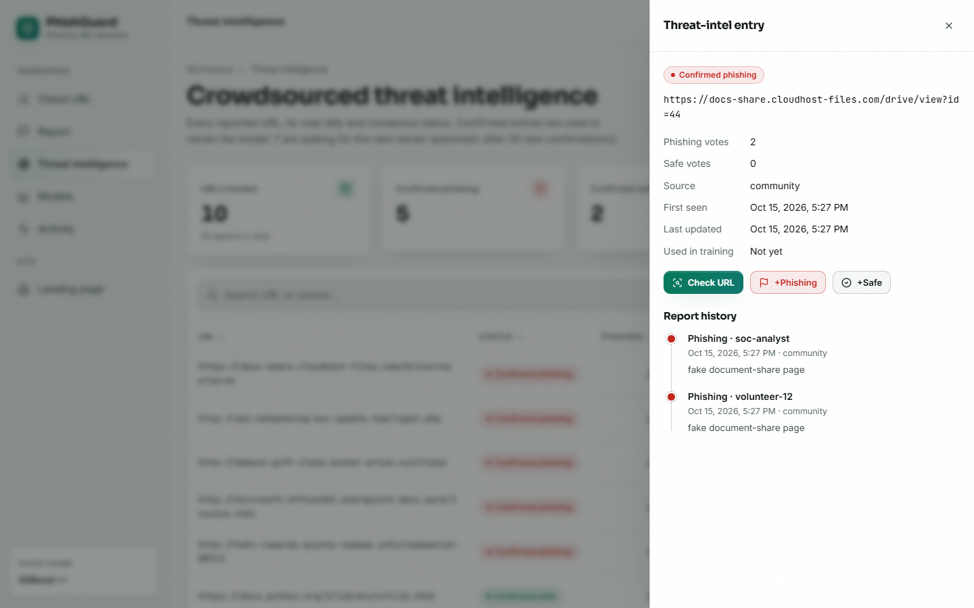  Fig. C.3: Threat-intelligence entry |   Fig. C.4: Models: comparison (version 1)

Threat-intelligence entry. The detail drawer of the document-share URL: status confirmed phishing, 2 phishing and 0 safe votes, source, first seen, not yet used in training, and the report history with reporter names and notes.
Models: comparison (version 1). The shipped models: XGBoost selected (F1 92.88 %, ROC-AUC 0.981, false-positive rate 6.38 %), trained on 32,000 and tested on 8,000 URLs.
  Fig. C.5: Activity |   Fig. C.6: Activity: full page

Activity. The check log: 56 checks, 36 flagged phishing, average probability 64.6 %, 10 decided by the community; a probability-per-check trend with the two thresholds dashed, and the verdict mix.
Activity: full page. The same page scrolled to the searchable table of every check with verdict, probability, decided-by and time.
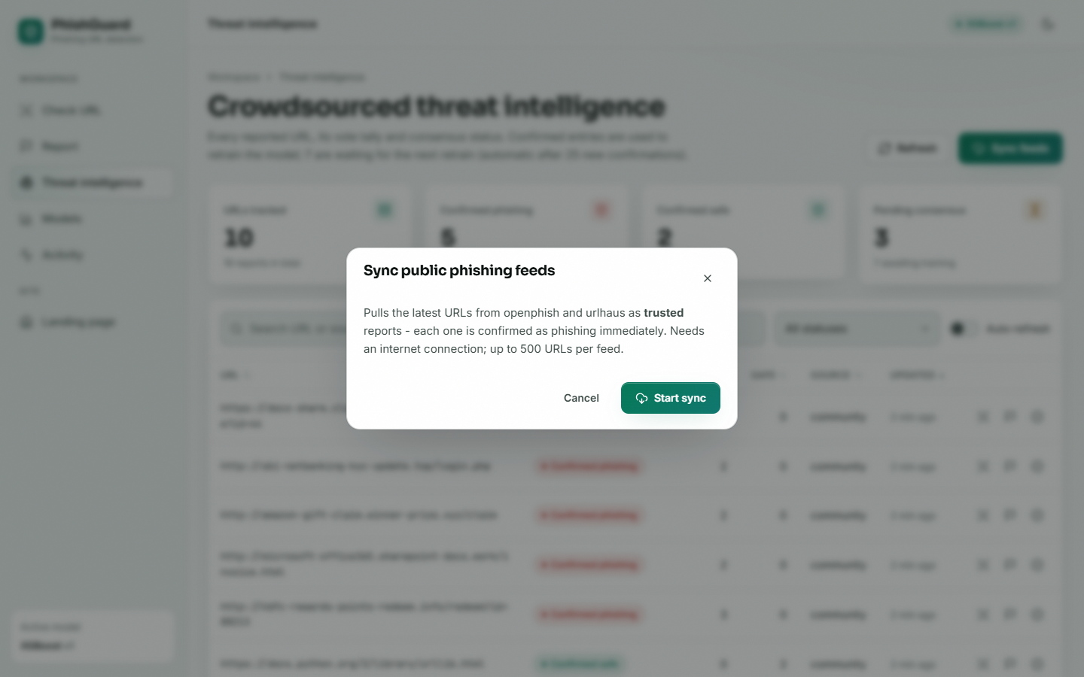  Fig. C.7: Feed sync: dialog | 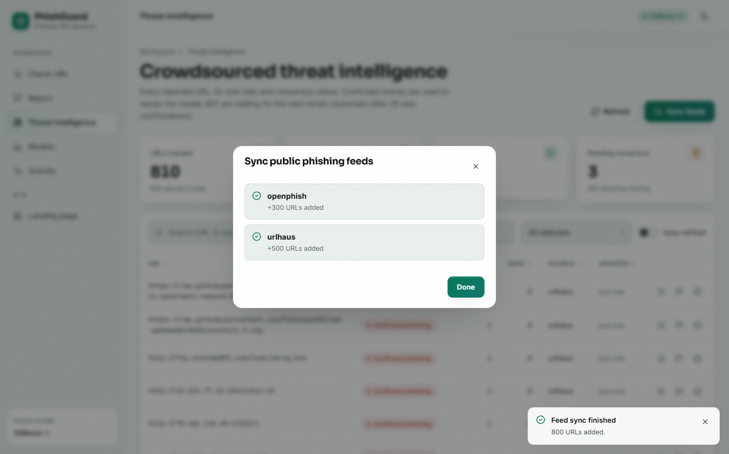  Fig. C.8: Feed sync: result

Feed sync: dialog. The dialog explains that URLs from OpenPhish and URLhaus are imported as trusted reports and confirmed as phishing at once.
Feed sync: result. The sync finished: openphish +300 URLs, urlhaus +500 URLs, 800 in total.
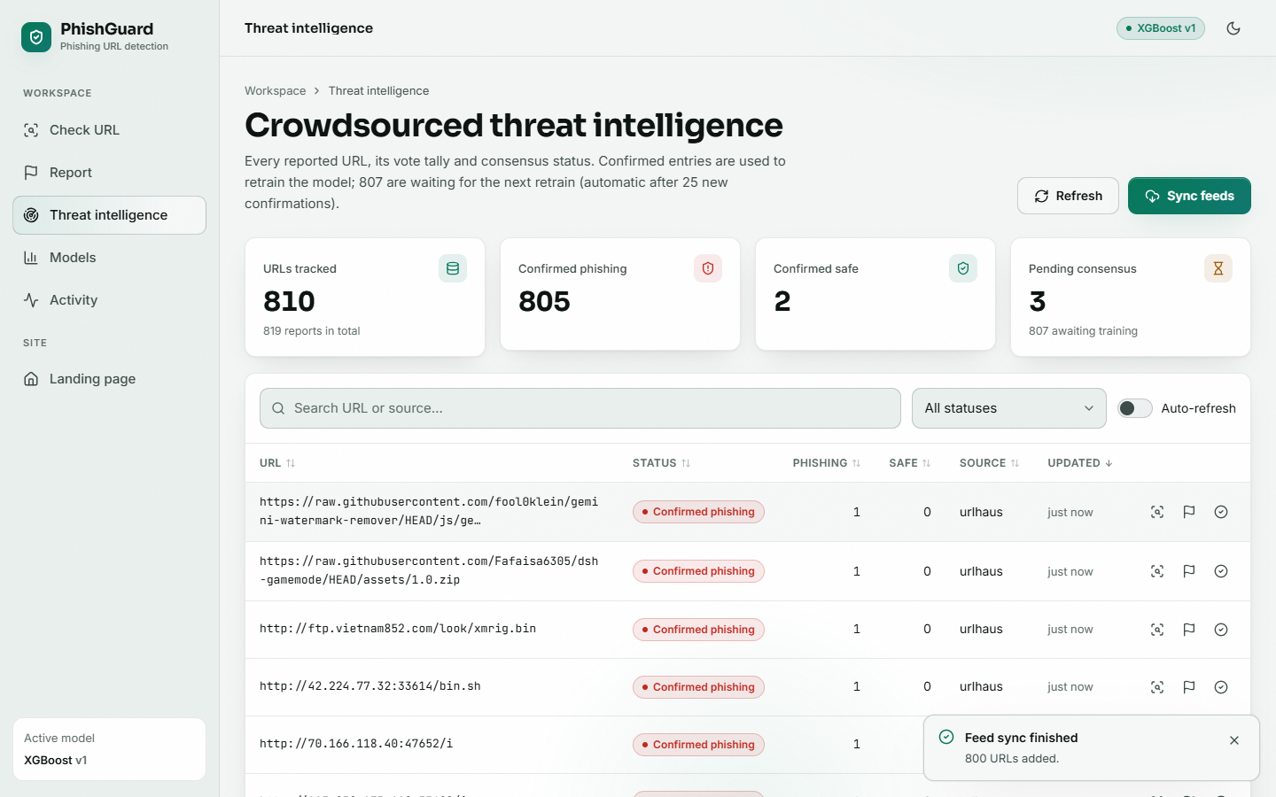  Fig. C.9: Threat intelligence after sync |   Fig. C.10: Retrain: confirmation

Threat intelligence after sync. The board now tracks 810 URLs, 805 of them confirmed phishing; the newest entries come from the feed.
Retrain: confirmation. Before retraining, the Models page asks for confirmation and states that the best model by F1 replaces the current one and checks keep working.
  Fig. C.11: Retrain: running |   Fig. C.12: Models: full page (version 2)

Retrain: running. While the retrain runs in the background the page shows a progress indicator and the topbar a Retraining badge.
Models: full page (version 2). Version 2 in full: XGBoost 92.91 % accuracy, confusion matrix 3,740 / 261 / 318 / 3,843, and 203.8 s training time recorded for that run.
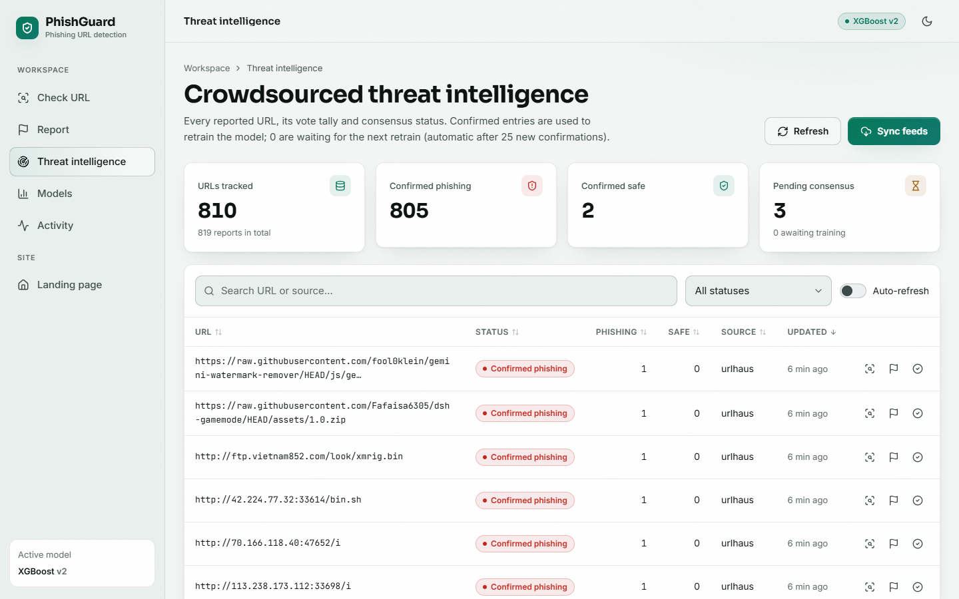  Fig. C.13: Threat intelligence after retraining |   Fig. C.14: Dark theme

Threat intelligence after retraining. After the retrain, 0 entries are awaiting training: every confirmed URL has been consumed. The list shows real URLhaus entries.
Dark theme. The same Check URL page in the dark theme.

